What’s the pHuss?
Introduction
It is important to know the acidic or basic nature of a liquid because the nature of the liquid often determines its use. Our stomach liquids are acidic so that specific enzymes can aid in digestion. Bathroom toilet bowl cleaners are strongly acidic or basic so that they can effectively clean. Automobile battery fluids are acidic so that electrical energy can be produced. The examples are all positive uses for acidity and/or basicity. Sometimes, however, there is too much of one or the other and problems arise. For example, if our stomachs are too acidic, we get a stomach ache.
Whether a liquid is acidic, basic, or neutral is measured by a quantity called pH. pH is a measure of how much hydrogen, in an ionic form, is in a solution. pH measurements are put on a scale from 1-14, with 1 being the most acidic and 14 being the most basic. If a solution has a pH of 7 it is said to be neutral. The pH scale is a "power of ten" scale. In other words, something with a pH of 9 is ten times as basic as something with a pH of 8.
The issue of acid deposition is one that has energy, environmental and scientific ramifications. One step in determining if a body of water has been affected by acid deposition is to measure its pH accurately over time and under various conditions. Since the major contributor to the acid deposition today is the burning of fossil fuels in cars, factories, and power plants, acid deposition is an energy issue.
Once students understand pH, they can be introduced to the idea that many familiar and innocent-looking substances may in fact be hazardous or toxic substances. They can learn to beware of the possible effects of these substances on health and the environment. All energy sources and many of the other conveniences of modern life have environmental consequences. Acid deposition is one which needs a great deal of study so that prompt and appropriate action can be taken.
Why Worry About Acid Rain?
Normal rain is actually somewhat acidic. And actually, water that is quite acidic may not be all dangerous for humans. After all, we can drink lemon juice, which has a pH of less than 3. But for plants and for animals that live in water, a low pH can be dangerous. If the pH of a lake drops below 5, it can have a serious impact on aquatic life.
What causes this acid rain? When carbon-based fossil fuels are burned, they release substances, some of which are acidic, into the air. They may settle out of the air, or mix with moisture in the air which causes rain or snow to become more acidic. Eventually all of the acidic substances get back to ground level. They fall on forests, fields, and lakes.
Not all fall as rain, though. It is really more accurate to say "acid deposition" rather than acid rain. The causes and effects of acid deposition are not completely understood. We do know that exhaust from cars, trucks, and buses are the main source of nitrogen oxides (NO₂). Factories, including smelters and electric generating plants, are the main source of sulfur dioxide (SO₂). It is unlikely that people will give up driving cars or using electricity. But we don’t want to damage our environment either. That is why today a lot of research is going on to pinpoint the causes and effects of acid deposition. When scientists study acid deposition, they are actually keeping an eye on the pH of our environment.
Measurements to be taken
In this investigation, students will measure the pH of a variety of substances.
Materials needed
- Mini with pH electrode
- Small bathroom sized paper cups
- Large plastic cup (16 oz. or larger)
- Distilled water
- Wash bottle or 30 ml syringe
- Variety of household liquids (possibilities include distilled water, tap water, lemon juice, vinegar, baking soda/water, orange juice, diluted oven cleaner, diluted ammonia, diluted bleach, cola beverage)
- pH data sheet (master attached)
Mini Set Up
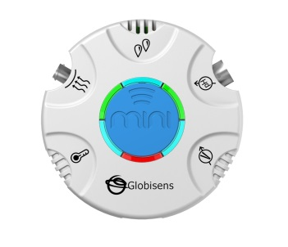For this experiment you will setup the Mini from the GlobiLab software menu. Use the directions in Getting to Know the Mini if you need assistance in setting up the Mini through the GlobiLab software.
- Sensor Selection - select pH
- Sampling Rate - Manual
- Number of Samples - select 100
The green LED lights will circle, and then pause for about 3 seconds at the pH electrode indicating that the pH electrode is “live.”
Experiment Set Up
Prior to the lab, dilute any strong acids or bases with distilled water. Then create sample sets of liquids to be tested. Each sample should be at least 50 ml in size. You can give each lab group the same samples or create different sets and have students share their results.
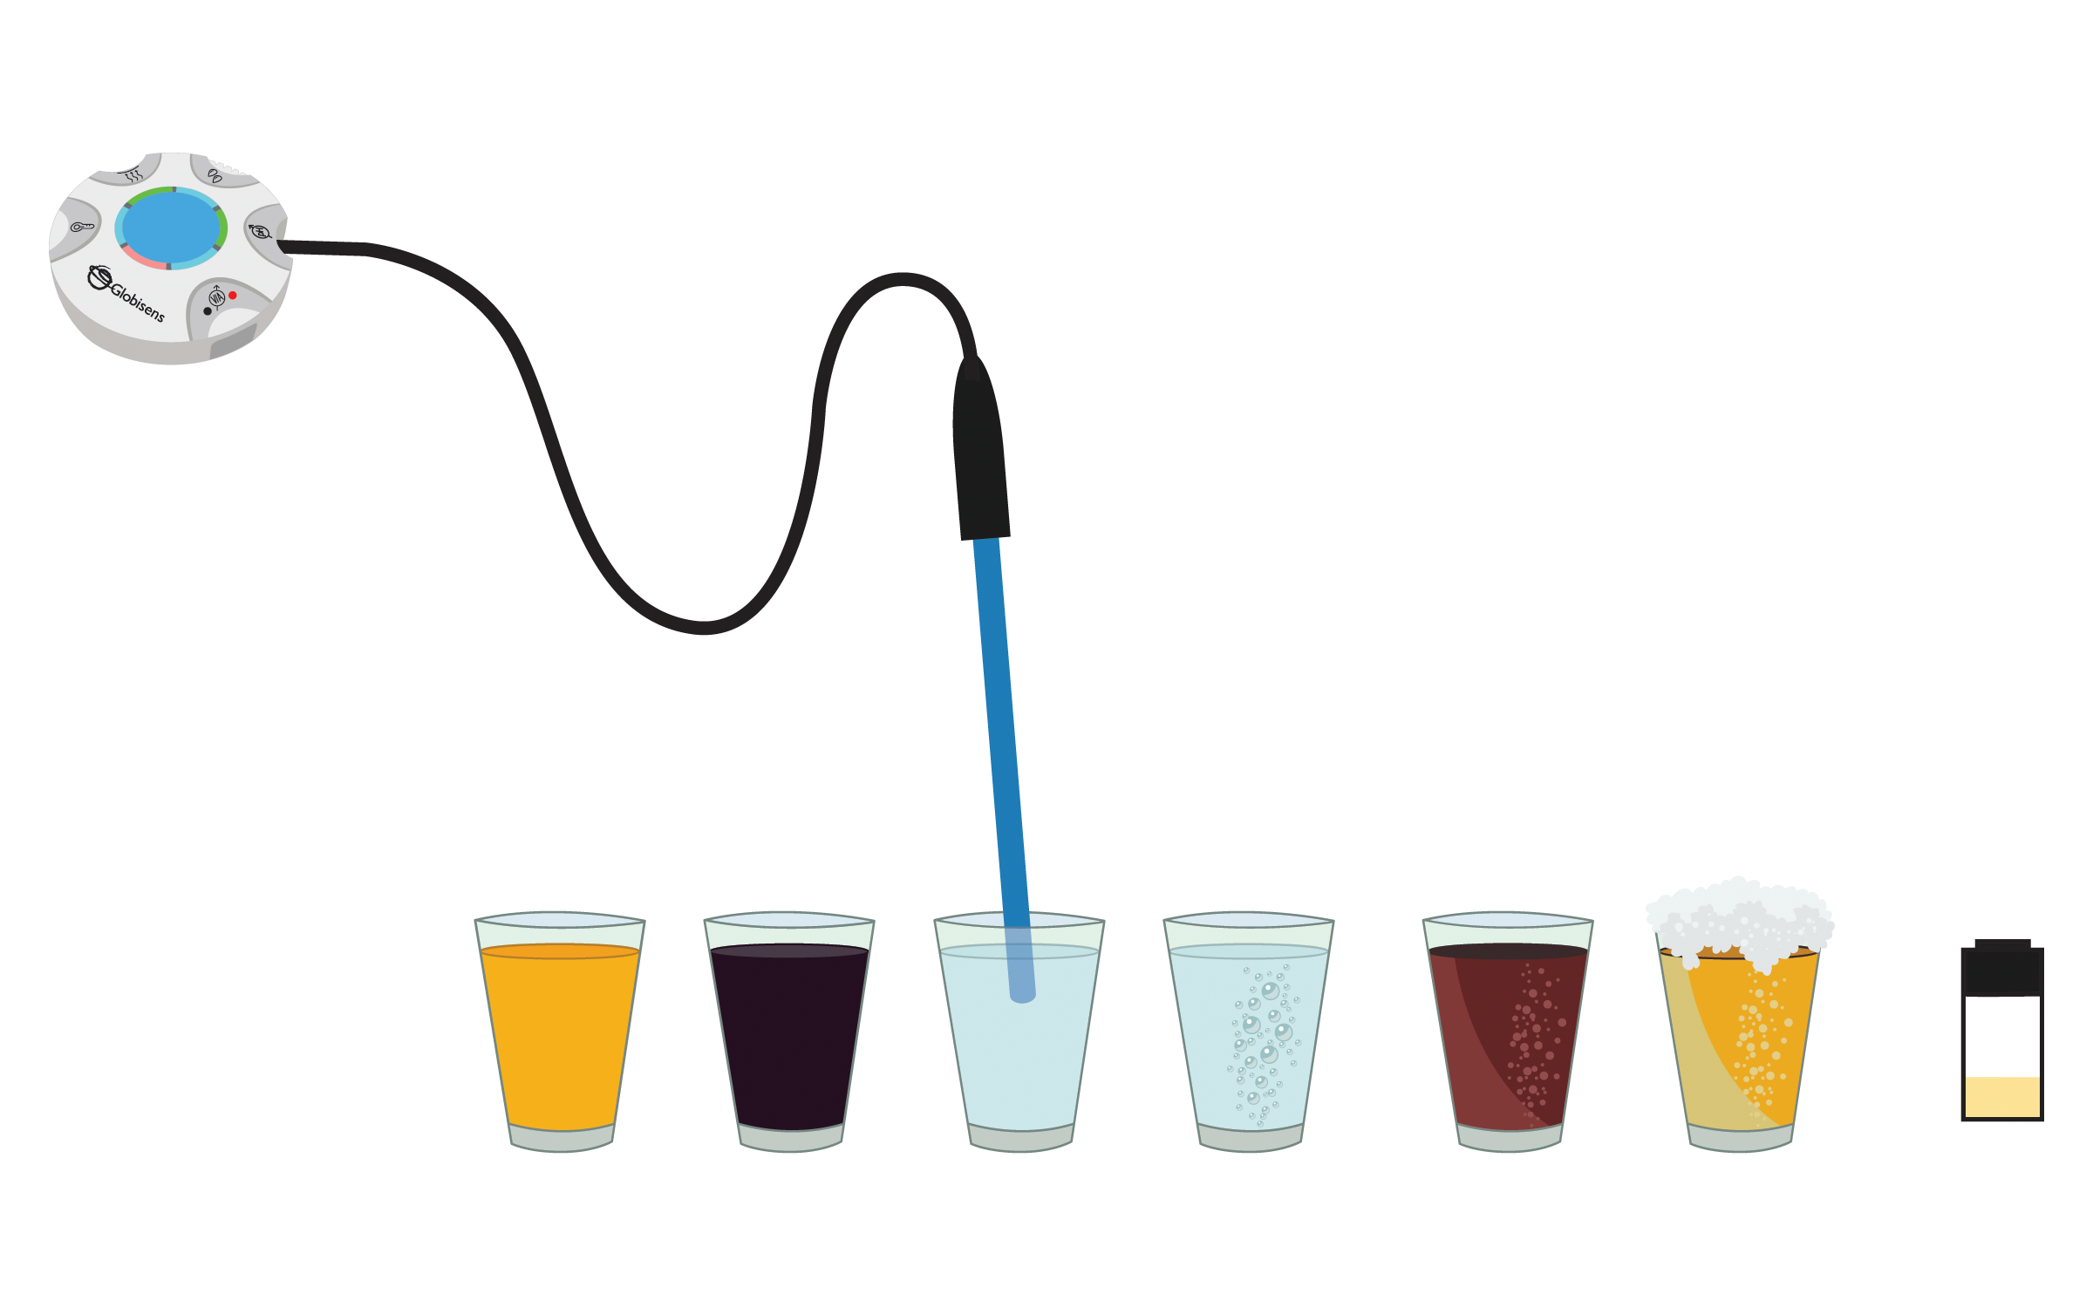
Experiment Procedure
- Dip the end of the pH electrode into the first liquid and stir gently for 10 seconds. Press the center blue button to record the pH.
- Use the wash bottle or the syringe to thoroughly rinse the pH electrode with distilled water. Do NOT dunk/stir the sensor in the cup of distilled water to rinse it as this will contaminate the distilled water and produce inaccurate readings.
- Record the pH and the classification of the substance tested on the data sheet.
- Repeat steps 1, 2 and 3 for each of the liquids. It is important to thoroughly rinse the sensor between each substance tested. Your graph will look something like this:
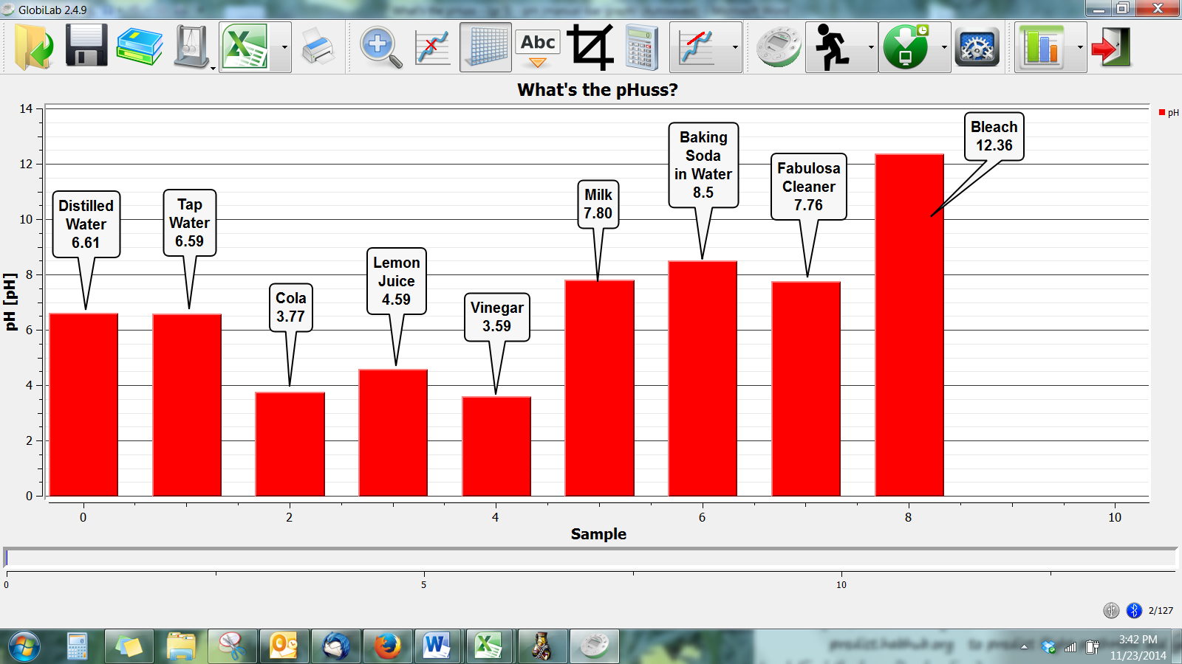
- Copy the information from your Data Table on the chalkboard so that other students can record your data.
- From the blackboard, copy information about other substances tested by other students.

Questions & Observations
- What are acids and bases?
- How do we measure them as scientists?
- What is the pH scale? What numbers on the scale describe acids? What numbers are bases?
- If water has a pH of 7, does that mean that nothing is dissolved in it?
- Why is pH important to the environment?
- Which substance(s) were/was the most acidic? Which was the most basic? Did this surprise you?
- Name one more common household item that you think is an acid. Name one that you think is a base. Explain why you think this.
Extension Activity
Make predictions about the pH of other household items and then test their pH.

What’s the pHuss?
Substance Tested | pH | Acid or Base

NGSS Standards

Performance Expectations
- Develop a model to describe that matter is made of particles too small to be seen. 5-PS1-1
- Make observations and measurements to identify materials based on their properties. 5-PS1-3

Science and Engineering Practices
- Using & Developing Models - Develop a model to describe phenomena.
- Planning & Carrying Out Investigations - Make observations and measurements to produce data to serve as the basis for evidence for an explanation of a phenomenon.

Disciplinary Core Ideas

S1.A: Structure and Properties of Matter
- Matter of any type can be subdivided into particles that are too small to see, but even then the matter still exists and can be detected by other means. A model showing that gases are made from matter particles that are too small to see and are moving freely around in space can explain many observations, including the inflation and shape of a balloon and the effects of air on larger particles or objects.
- Measurements of a variety of properties can be used to identify materials. (Boundary: At this grade level, mass and weight are not distinguished, and no attempt is made to define the unseen particles or explain the atomic-scale mechanism of evaporation and condensation.)

Crosscutting Concepts

Scale, Proportion, and Quantity
- Natural objects exist from the very small to the immensely large.
- Standard units are used to measure and describe physical quantities such as weight, time, temperature, and volume.

Common Core State Standards Connections

ELA/Literacy
- RI.5.7 - Draw on information from multiple print or digital sources, demonstrating the ability to locate an answer to a question quickly or to solve a problem efficiently.
- W.5.8 - Recall relevant information from experiences or gather relevant information from print and digital sources; summarize or paraphrase information in notes and finished work, and provide a list of sources.
- W.5.9 - Draw evidence from literary or informational texts to support analysis, reflection, and research.

Mathematics
5.NBT.A.1 - Recognize that in a multi-digit number, a digit in one place represents 10 times as much as it represents in the place to its right and 1/10 of what it represents in the place to its left.

