What is the Weather Like Today and How Is It Different from Yesterday?
Introduction
Weather Reports

Weather is the state of the atmosphere around us. It can be hot or cold, wet or dry, calm or stormy, clear or cloudy. Weather generally refers to day-to-day temperature and precipitation activity, whereas climate is the term for the average atmospheric conditions over longer periods of time. Most weather phenomena occur in the troposphere, just below the stratosphere. When used without qualification, "weather" is understood to mean the weather of Earth.
Different weather reports contain different amounts of information. The simplest and shortest weather report contains only one piece of information, the present temperature. More detailed weather reports contain information about precipitation, relative humidity, barometric pressure, and more.
Often a weather report tells you the highest and lowest temperatures for the past day. The day’s lowest temperature usually occurs just after sunrise. The day’s highest temperature is usually reached during early to mid-afternoon. The may also give you the average temperature for the day. The average daily temperature lies halfway between the highest temperature and the lowest temperature.
Most weather reports give the amount of precipitation, if any fell during the past day. They also tell you the totals for the current month and the current year. Reports also indicate how much the monthly and annual precipitation totals are above or below normal (the long-term average).
Weather Forecasts
People are usually most interested in what the weather will be tomorrow or in the next few days. Meteorologists make both short-term (up to one week) and long-term (a month, a season, or a year) forecasts of the weather . Long-term forecasts are sometimes called outlooks. Long-range outlooks are different from short-term forecasts in that they predict departures of temperature and precipitation from long-term averages (e.g. colder or warmer than normal, wetter or drier than normal).
Many years ago, the only way of predicting the weather was to use local experiences. The next day’s weather was often predicted based on the previous day’s weather. As you can imagine, the success of such forecasting was not much better than making a random guess.
Once the national weather service began to gather weather observations from weather stations located over large areas of the country, simultaneous weather observations allowed meteorologists to plot weather maps and follow weather systems as they moved from place to place, greatly improving the accuracy of weather forecasts. Through the 20th century, meteorologists developed even better tools for observing and predicting the weather.
The science of weather forecasting is still developing. Weather prediction will never be perfect. Small changes in the weather in one place can cause much larger changes in weather elsewhere. The effects are small at first, but they become much greater. It’s very difficult to predict these interactions. Although forecasts will never be perfect, they will continue to improve in the years ahead. Through research, meteorologists learn more and more about the details of how weather in the Earth system works.
Measurements to be taken
In this investigation, students will measure daily weather conditions including temperature, humidity, air pressure and precipitation. Measurements will be taken from a designated weather station located on the school grounds on an on-going basis throughout the school year and recorded as a class on a daily basis.
Materials needed
- Mini
- Rain gauge
- Vented protective housing for Mini
- Weather Calendar Bulletin Board with weather symbols
- Weather Calendar Worksheet (master attached)
Information about protective weather boxes can be found at:
http://www.weatherforschools.me.uk/html/weatherboxes.html

Directions to build a protective weather instrument box can be found at:
https://www.globe.gov/documents/348614/348678/atinst.pdf
Mini Set Up
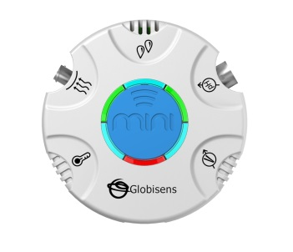For this experiment you will setup the Mini from the GlobiLab software menu. Use the directions in Getting to Know the Mini if you need assistance in setting up the Mini through the GlobiLab software.
- Sensor Selection - select Ambient Temperature
- Sampling Rate - Manual
- Number of Samples - select 100
When you push the Run button, the green LED lights will circle, indicating that the Mini is in Manual data collection mode.
Experiment Set Up
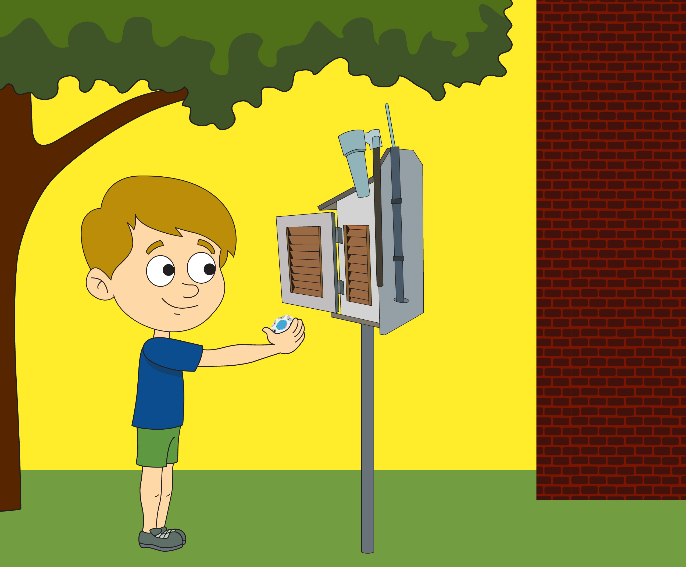
- Select a place in your school yard that is shaded from the sun and at least 1 meter from any buildings to set up your weather station. The protective box should be placed on a stand at least 60 cm tall (like a picnic table or an overturned trash can or a pole). You want to be sure that heat from the ground or buildings doesn’t interfere with your measurements.
- Attach your rain gauge to side of the protective box so that it does not interfere with opening the box and is not covered by any part of the box’s roof.
- Set up your Weather Calendar bulletin board. It should be a large calendar, showing one week at a time. Cut out or purchase paper thermometers, suns, clouds, clouds with lightening, clouds with snow flakes and clouds with raindrops. You will use these to post the daily temperatures and weather. The space for each day should be big enough to post information from three times during the school day (perhaps the beginning of the day, end of the day and lunch time).
Experiment Procedure
Start the GlobiLab software from the computer/tablet and place the Mini in the weather station box.
- Allow the Mini to sit in the weather station for at least 30 minutes before taking your first measurement. To take a measurement, simply press the blue control key in the center of the Mini. Return the Mini to the weather station and close the door.
- At this time, also start recording the daily weather conditions. Pick three times during the day to post the current weather conditions with a symbol on the Weather Data bulletin board. Be sure to take a measurement with the Mini at these same times. Collect this data at the same time every day.
- Be sure to check and empty your rain gauge daily and make a note of the amount of precipitation collected. Save this information you will use it at the end of the activity. Be sure to do check your rain gauge at the same time each day – starting 24 hours after you set up your weather logging station.
- At the end of the week, collect the Mini from the weather station box and connect it to the GlobiLab software. Download and save the data with the week’s date. Return the Mini to the weather station box.
- Project the GlobiLab graph so that all students can see a bar graph of all of the temperatures collected during the week. Label each bar with day and time of the data collection. Your graph will look something like this:
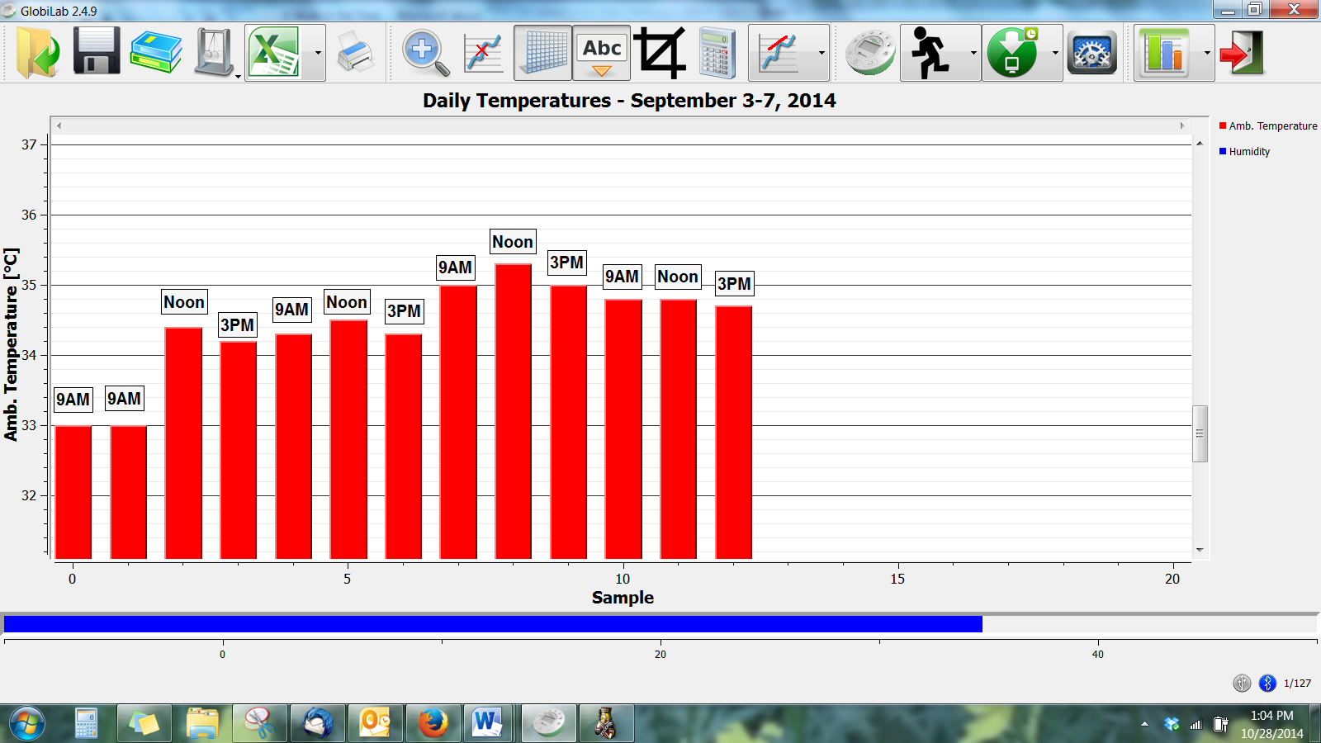
- Identify where the graph shows higher temperatures and where it shows lower temperatures.
- Write the temperatures on the paper thermometers and post to the Daily Weather calendar next to the symbols representing that day’s weather conditions at the same time. Students should also draw pictures and fill in the temperatures on their calendar worksheets.
- Repeat steps 6 and 7 with the humidity measurements.
- After answering the questions below, take a picture of the week’s calendar so that you can compare your information with information from other weeks and other schools.
Questions & Observations
- During what time of day were the temperatures the highest? The lowest?
- What happened to the temperatures between morning and lunch? Between lunch and the end of the day? What do you think happened at dinner time? At bed time?
- Look at the week’s weather graph. Are there places where the graph bars do not change where you thought they would? What could have caused these changes? What kind of weather conditions were happening at the time of the change?
- What kind of weather makes the temperature warmer? What kind of weather makes temperatures cooler?

NGSS Standards

Performance Expectations
Use and share observations of local weather conditions to describe patterns over time. K-ESS2-1

Science and Engineering Practices
- Ask questions based on observations to find more information about the designed world. K-ESS3-2
- Make observations (firsthand or from media) to collect data that can be used to make comparisons. K-PS3-1
- Use observations (firsthand or from media) to describe patterns in the natural world in order to answer scientific questions. K-ESS2-1
- Scientists look for patterns and order when making observations about the world. K-ESS2-1
- Scientists use different ways to study the world. K-PS3-1

Disciplinary Core Ideas
- ESS2.D: Weather and Climate
  - Weather is the combination of sunlight, wind, snow or rain, and temperature in a particular region at a particular time. People measure these conditions to describe and record the weather and to notice patterns over time.
- Patterns - Patterns in the natural and human designed world can be observed, used to describe phenomena, and used as evidence. K-ESS2-1
  - Cause and Effect - Events have causes that generate observable patterns.

Common Core State Standards Connections

ELA/Literacy
- RL.K.1 - With prompting and support, ask and answer questions about key details in a text.
- SL.K.3 - Ask and answer questions in order to seek help, get information, or clarify something that is not understood.
- W.K.7 - Participate in shared research and writing projects.

Mathematics
- K.CC - Counting and Cardinality
- K.CC.A - Know number names and the count sequence.
- K.MD.A.1 - Describe measurable attributes of objects, such as length or weight. Describe several measurable attributes of a single object.
- K.MD.A.2 - Directly compare two objects with a measurable attribute in common, to see which object has "more of"/"less of" the attribute, and describe the difference.
- K.MD.B.3 - Classify objects into given categories; count the numbers of objects in each category and sort the categories by count.
- MP.2 - Reason abstractly and quantitatively.
- MP.4 - Model with mathematics.

Weather Calendar
Monday | Tuesday | Wednesday | Thursday | Friday

