What’s It Like Out There?
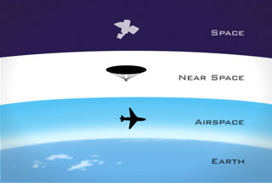
Real space starts at around 80 kilometers (about 260,000 feet). Near space, the region of the Earth's atmosphere between 20 and 100 km (65,000 and 328,000 feet) above sea level, encompasses the stratosphere, mesosphere, and the lower thermosphere is more accessible for student research with a high altitude weather balloon. Near space is above where commercial airliners fly but below orbiting satellites.
The high-altitude near-space weather balloon used for this activity can climb to altitudes of up to 30 kilometers (80,000 feet). That is about three times the altitude of Mount Everest or three times the altitude that a passenger plane flies at. From that height the mission photographs show the curve of the Earth and a number of different data parameters can be collected.
This is not intended to provide you with instruction on how to launch a high-altitude near-space weather balloon into near space, but rather to address how the use of a Labdisc can enhance and simplify the data collection done by such a weather balloon. A list of resources for equipment and instruction can be found at the end of this activity.
What To Do
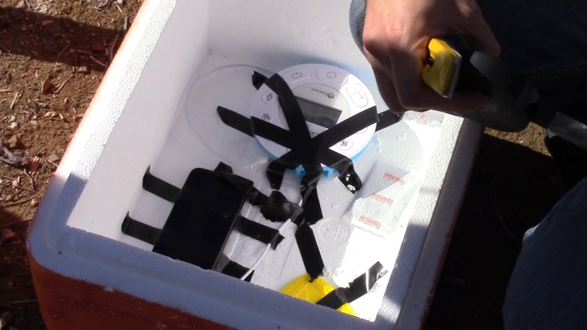
Include a Labdisc GenSci or Labdisc Enviro as part of the payload of a high-altitude near-space weather balloon to record temperature, air pressure, sound and GPS location during the high-altitude weather balloons ascent and descent. Additional equipment in the payload could include a HD video camera and GPS tracking unit to ensure that you recover the balloon’s payload.
1. Develop a list of questions that you’d like to answer about conditions in near space. Brainstorm with students how you might go about getting data to answer those questions. Student answers may include suggestions like rocket, space ship or airplane. If they do not suggest it, using the Socrative method, guide student discussion toward the idea of a balloon. Do some research about high-altitude near-space weather balloons to develop a plan to launch your own high-altitude near-space weather balloon. A list of resources can be found on the last page.
2. Design/produce your payload carrier. Many high-altitude near-space weather balloon projects use an inexpensive polystyrene cooler. This type of container offers protection from both physical impact and the external conditions and allows for easy construction of portals for your camera, external temperature probe and any other equipment that needs to be exposed to the conditions of near space. It is not necessary for the air pressure tube to be used, nor to have the air pressure sensor with an outside contact.
Make sure that your equipment is securely attached inside the payload container. You may wish to include some type of stabilizing structure on the outside of your payload to minimize movement and to ensure a smooth video of your flight. It is also recommended that you use a disposable hand warmer to ensure that the temperatures inside the payload box do not affect the battery performance of your electronics.
3. Set up your Labdisc to record temperature, air pressure & sound. Make sure that the GPS is enabled and that the battery is fully charged. Set a sample rate of 1/second and a sample size of 10000. You will start the Labdisc at the launch site using the Scroll/Start key shortly prior to the balloon’s launch. A high-altitude, near-space weather balloon will fly for approximately 90 minutes. These settings are more than adequate to ensure that you record your entire flight including ascent, descent and landing.
4. Consider adding some additional experiments to the payload. This might include sending items into near space to evaluate the effect on these items. This might include seeds, food items or plants. These items should be contained in small plastic holders/boxes. Do not include any living creatures.
5. Develop a plan for retrieving your payload after it has landed. It is recommended that you clearly label the outside of your payload container with information indicating that it is a harmless student science project as well as providing contact information/phone number. You may wish to consider indicating that there is a cash reward to increase the chances of getting your payload back.
6. After the flight and the retrieval of your payload, download your data from the Labdisc to the Globilab software. You may find that for a portion of the trip, the environmental conditions exceed the air pressure and temperature measurement ranges of the Labdisc. Labdisc capabilities are listed below. If this occurs, you will need to mathematically extrapolate the data based on the other portions of the trip. Use the air pressure readings to calculate your balloon’s altitude at various portions of the flight. Your graphs will resemble the ones on the following pages.
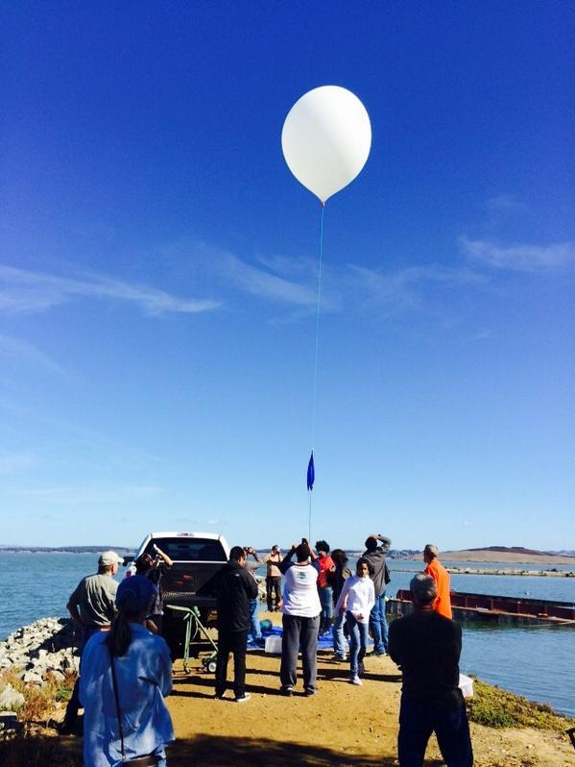
Labdisc Sensor Capabilities
Icon | Type | Range | Description | Max Sample Rate | External Accessories
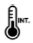 | Ambient Temperature | -10◦C to 50◦C | Measuring ambient temperature | 1/sec | None needed
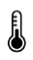 | External Temperature | -25◦C to 125◦C | All purpose stainless steel temperature probe | 10/sec | Temp probe
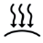 | Air Pressure | 0 to 300 kPa | Measuring air pressure | 10/sec | None needed
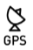 | GPS | N/A | Measuring longitude, latitude, course speed, date & time | 1/sec | None needed

Data Graphs from a High-Altitude Near-Space Balloon Flight
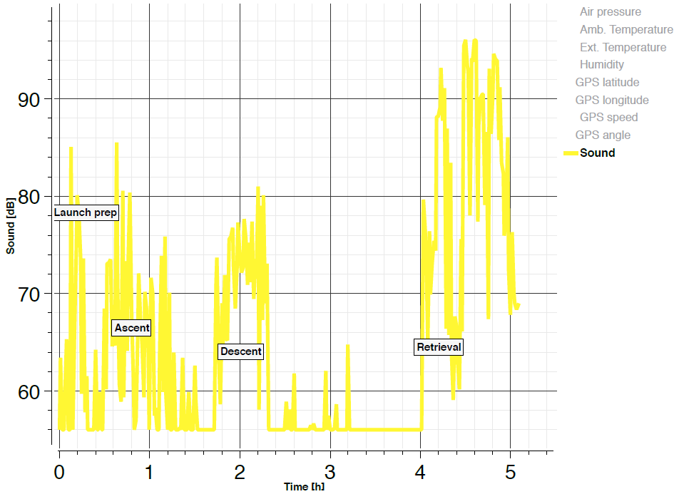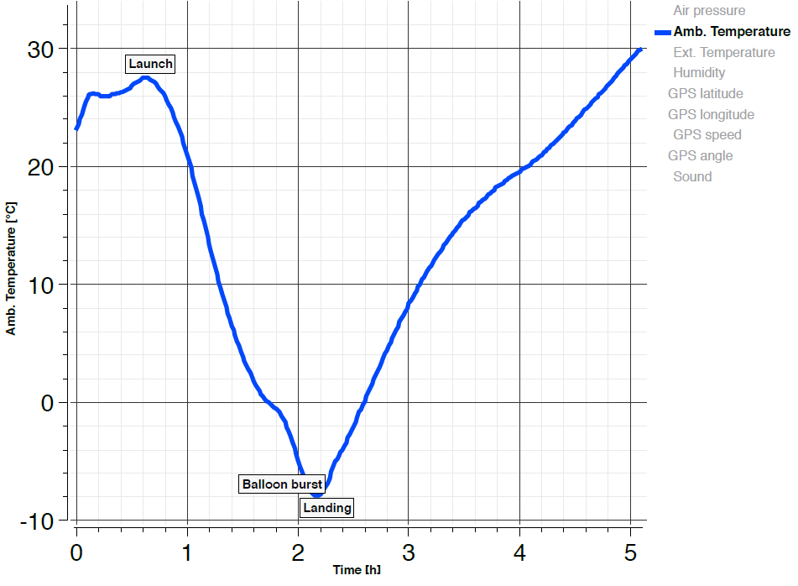
Sound Data Temperature Inside the Payload
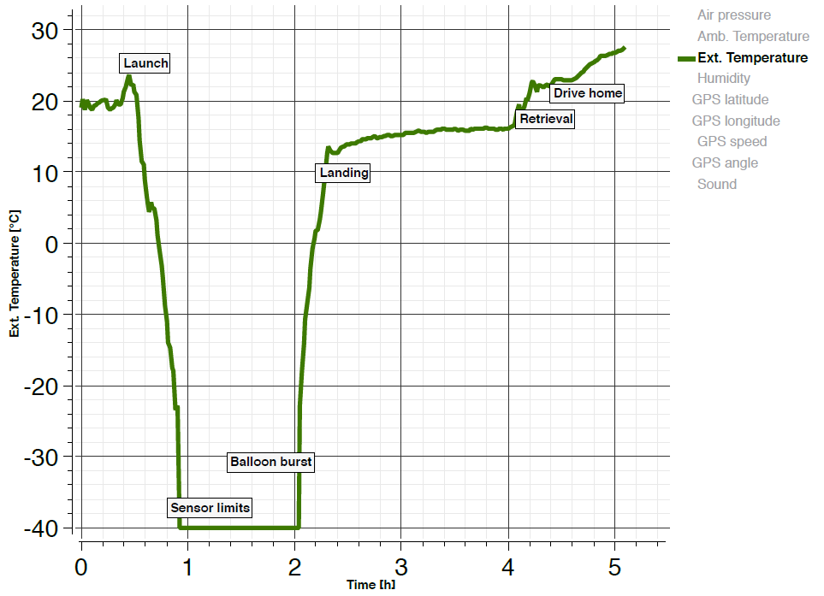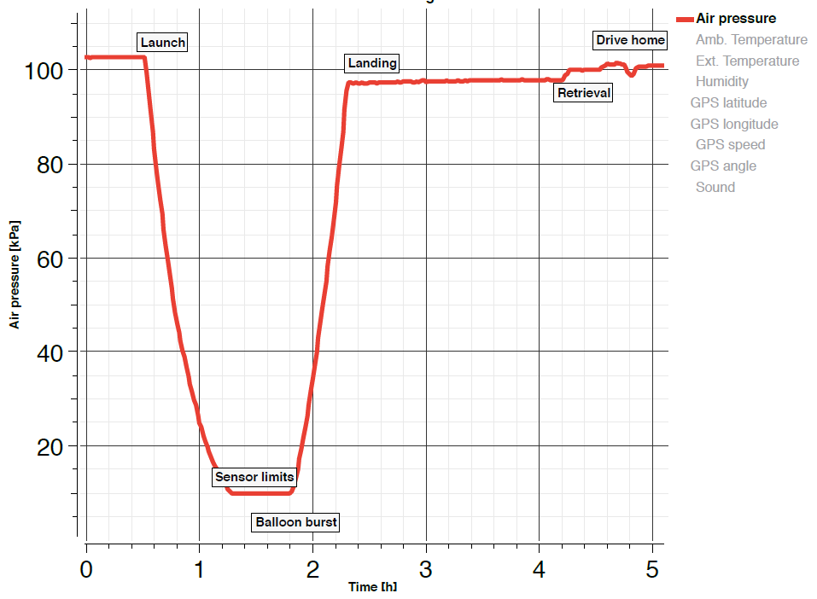
External Temperature Data Air Pressure Data

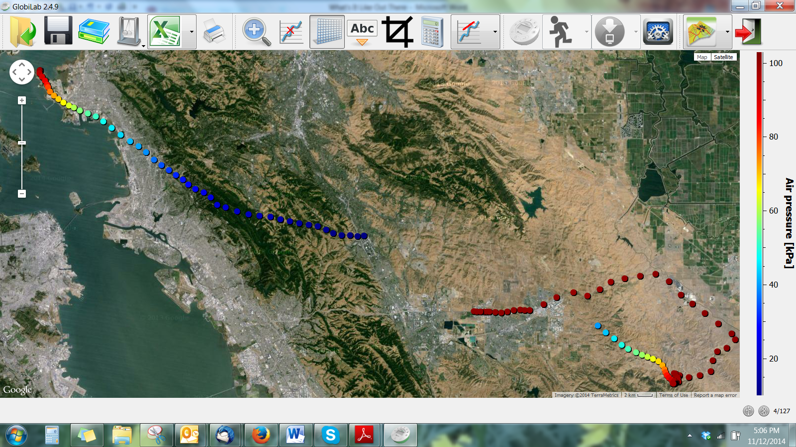
Air pressure data on Google Maps overlay
Images from High-Altitude Near-Space Balloon Flights
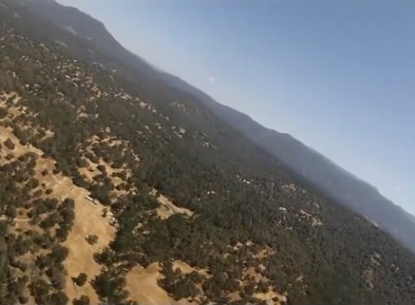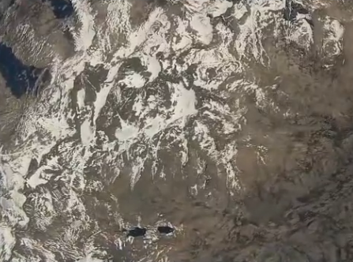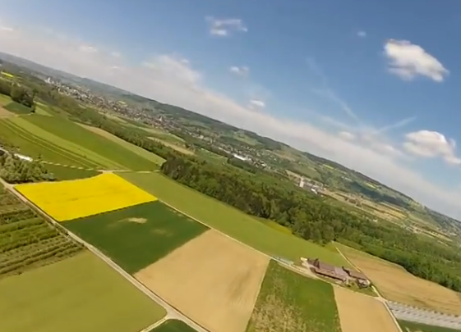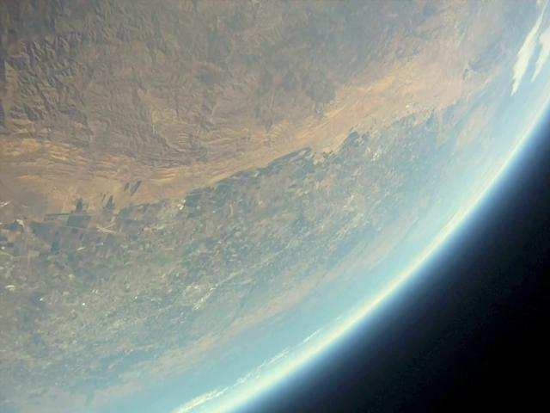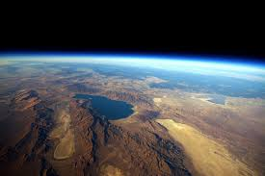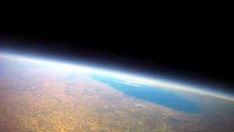

Other Suggestions/Advice
- Be sure to communicate with the local authorities like the Federal Aviation Authority or the Civil Air Authorities prior to your launch to ensure that you are in compliance with any laws regarding flights into near space. In the United States, payloads under 6 pounds do not need approval from the FAA.
- Choose your launch site carefully. Consider potential interference with local airports and other businesses.
- Use appropriate tools to accurately predict your balloons flight path/route and anticipated landing zone. Be careful to plan flights that will land in areas that are not too urban or in hospitable to retrieving your payload. One source to help predict your balloon’s flight path is http://predict.habhub.org.
- Practice a tethered flight prior to your high-altitude near-space launch. This will give you a chance to become familiar with the launch process and provide an initial chance to analyze data and may help improve predictions for the high-altitude launch.
- Don’t use the cheapest electronics available. You will be investing significant time, effort and finances into this venture. You want to be sure that you are able to retrieve your payload and that you are successful in photographing and data collection.
- Avoid using a cell phone as your GPS locator. Your payload may land in an area with weak or no cellular signal and in some areas it is illegal to fly a functioning cell phone at higher altitudes.
- Consider purchasing duplicates of some key items to avoid last minute equipment failure cancelling your launch. (i.e. balloon, GPS tracker)
- Always wear rubber gloves when handling the balloon to protect it from body oils and damage
Ask Yourself
- How long did your balloon fly before bursting?
- How much longer was it aloft before landing?
- How far did your balloon travel from the launch site? Did your balloon’s flight match your predictions? What conditions affected this?
- What kind of patterns did you observe in the data that was collected?
- Where did you observe the most extreme readings (highest and lowest) for each parameter being measured?
- Theorize why you think these conditions happened at these points.
- Where did the most rapid changes occur? Why do you think this is?
- If you sent items besides the electronics into near-space, how (if at all) were the items affected? How will you know? Design a way to test the effects of near space exposure on the payload items.

Now What?
- Develop a poster or a PowerPoint presentation to share the information you collected.
- Share the presentation with…. Your class…. Your school…. Your parents….. The internet….
Near Space Resources
These resources listings are not endorsed by Globisens and Labdisc but are merely a representative sample of the sources for equipment and information about high-altitude, near-space weather balloons
Source of weather balloons, parachutes and hardware
Full Weather Balloon kits
StratoStar (US) http://www.stratostar.net/educators.html
StratoFlights (Germany) http://www.stratoflights.com/en/
Weather Balloon Components
Kaymont Balloons http://kaymontballoons.com/Near_Space_Photography.html
Rocketman Parachutes http://www.the-rocketman.com/recovery.html
Spot Trace GPS tracker http://tinyurl.com/mz2qkcm
Other Useful Sites
Predict your balloon’s flight path http://predict.habhub.org
Balloon Ascent Rate Calculator http://tinyurl.com/mkjb9zy
Calculate altitude from air pressure data http://tinyurl.com/lqghgl5
Groups Conducting High-Altitude Near-Space Weather Balloon Flights
NASA NOVAS - NASA Opportunities in Visualization, Art & Science (US) http://www.nasanovas.org/
Hi-Impact Educational Consultancy (UK) http://tinyurl.com/nsgwn3t
Nebraska High-Altitude Ballooning Adventures/Near Space Science (US) http://tinyurl.com/lz5ytvh
Amateur Radio High Altitude Ballooning/Near Space Systems (US) http://www.nearsys.com/arhab/arhab.htm
Near Space Ventures (UK) http://tinyurl.com/pyovsnm
Videos of Student Projects
These videos are not a how-to with instructions, but demonstrate the data collection results of high-altitude, near-space weather balloon flights conducted by students of varying ages. Their inclusion is neither a validation of their results nor an endorsement of the project quality but simply a representative sampling of student projects.
http://tinyurl.com/kf9syc5  http://tinyurl.com/mpugvvv  http://tinyurl.com/prvzzkf | http://tinyurl.com/okem5gl  http://tinyurl.com/prvzzkf
How-to Videos
These videos were done by the German company StratoFlights (http://www.stratoflights.com/en/). Although in German, they are very clear in visually showing the basics of preparing a high-altitude near-space weather balloon launch. StratoFlights also offers equipment for sale at http://tinyurl.com/m3ao3xs

