Weather & Climate
Introduction
Weather Reports
Weather is the state of the atmosphere around us. It can be hot or cold, wet or dry, calm or stormy, clear or cloudy. Weather generally refers to day-to-day temperature and precipitation activity, whereas climate is the term for the average atmospheric conditions over longer periods of time. Most weather phenomena occur in the troposphere, just below the stratosphere. When used without qualification, "weather", is understood to mean the weather of Earth.
Different weather reports contain different amounts of information. The simplest and shortest weather report contains only one piece of information, the present temperature. More detailed weather reports contain information about precipitation, relative humidity, barometric pressure, and more.
Often a weather report tells you the highest and lowest temperatures for the past day. The day’s lowest temperature usually occurs just after sunrise. The day’s highest temperature is usually reached during early to mid-afternoon. The may also give you the average temperature for the day. The average daily temperature lies halfway between the highest temperature and the lowest temperature.
Most weather reports give the amount of precipitation, if any, fell during the past day. They also tell you the totals for the current month and the current year. Reports also indicate how much the monthly and annual precipitation totals are above or below normal (the long-term average).
Weather Forecasts
People are usually most interested in what the weather will be tomorrow or in the next few days. Meteorologists make both short-term (up to one week) and long-term (a month, a season, or a year) forecasts of the weather. Long-term forecasts are sometimes called outlooks. Long-range outlooks are different from short-term forecasts in that they predict departures of temperature and precipitation from long-term averages (e.g., colder or warmer than normal, wetter or drier than normal).
Many years ago, the only way of predicting the weather was to use local experiences. The next day’s weather was often predicted based on the previous day’s weather. As you can imagine, the success of such forecasting was not much better than making a random guess.
Once the national weather service began to gather weather observations from weather stations located over large areas of the country, simultaneous weather observations allowed meteorologists to plot weather maps and follow weather systems as they moved from place to place, greatly improving the accuracy of weather forecasts. Through the 20th century, meteorologists developed even better tools for observing and predicting the weather.
The science of weather forecasting is still developing. Weather prediction will never be perfect. Small changes in the weather in one place can cause much larger changes in weather elsewhere. The effects are small at first, but they become much greater. It’s very difficult to predict these interactions. Although forecasts will never be perfect, they will continue to improve in the years ahead. Through research, meteorologists learn more and more about the details of how weather in the Earth system works.
Measurements to be taken
In this investigation, students will measure daily weather conditions including temperature, humidity, air pressure and precipitation. Measurements will be from a designated weather station located on the school grounds. Measurements will be taken on an on-going basis throughout the school year and recorded as a class on a daily basis.
Materials needed
- Mini
- Rain gauge
- Vented protective housing for Mini
- Weather Calendar Bulletin Board with weather symbols
- Weather Calendar Worksheet (master attached)
Information about protective weather boxes can be found at:
http://www.weatherforschools.me.uk/html/weatherboxes.html

Directions to build a protective weather instrument box can be found at:
https://www.globe.gov/documents/348614/348678/atinst.pdf
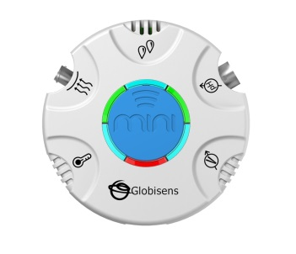Mini Set Up
For this experiment you will setup the Mini from the GlobiLab software menu. Use the directions in Getting to Know the Mini if you need assistance in setting up the Mini through the GlobiLab software.
- Sensor Selection - select the Ambient Temperature, Humidity & Air Pressure
- Sampling Rate - Manual
- Number of Samples - select 100
When you push the Run button, the green LED lights will circle, indicating that the Mini is in Manual data collection mode.
Experiment Set Up
- Select a place in your school yard that is shaded from the Sun and at least 1 meter from any buildings to set up your weather station. The protective box should be placed on a stand at least 60 cm tall (like a picnic table or an overturned trash can or a pole). You want to be sure that heat from the ground or buildings doesn’t interfere with your measurements.
- Attach your rain gauge to the side of the protective box so that it does not interfere with opening the box and is not covered by any part of the box’s roof.
- Set up your Weather Graph bulletin board. You will use these to graph the daily temperature, humidity & air pressure readings as well as the local weather conditions. The space for each day should be big enough to post information from three times during the school day (perhaps the beginning of the day, end of the day and lunch time).
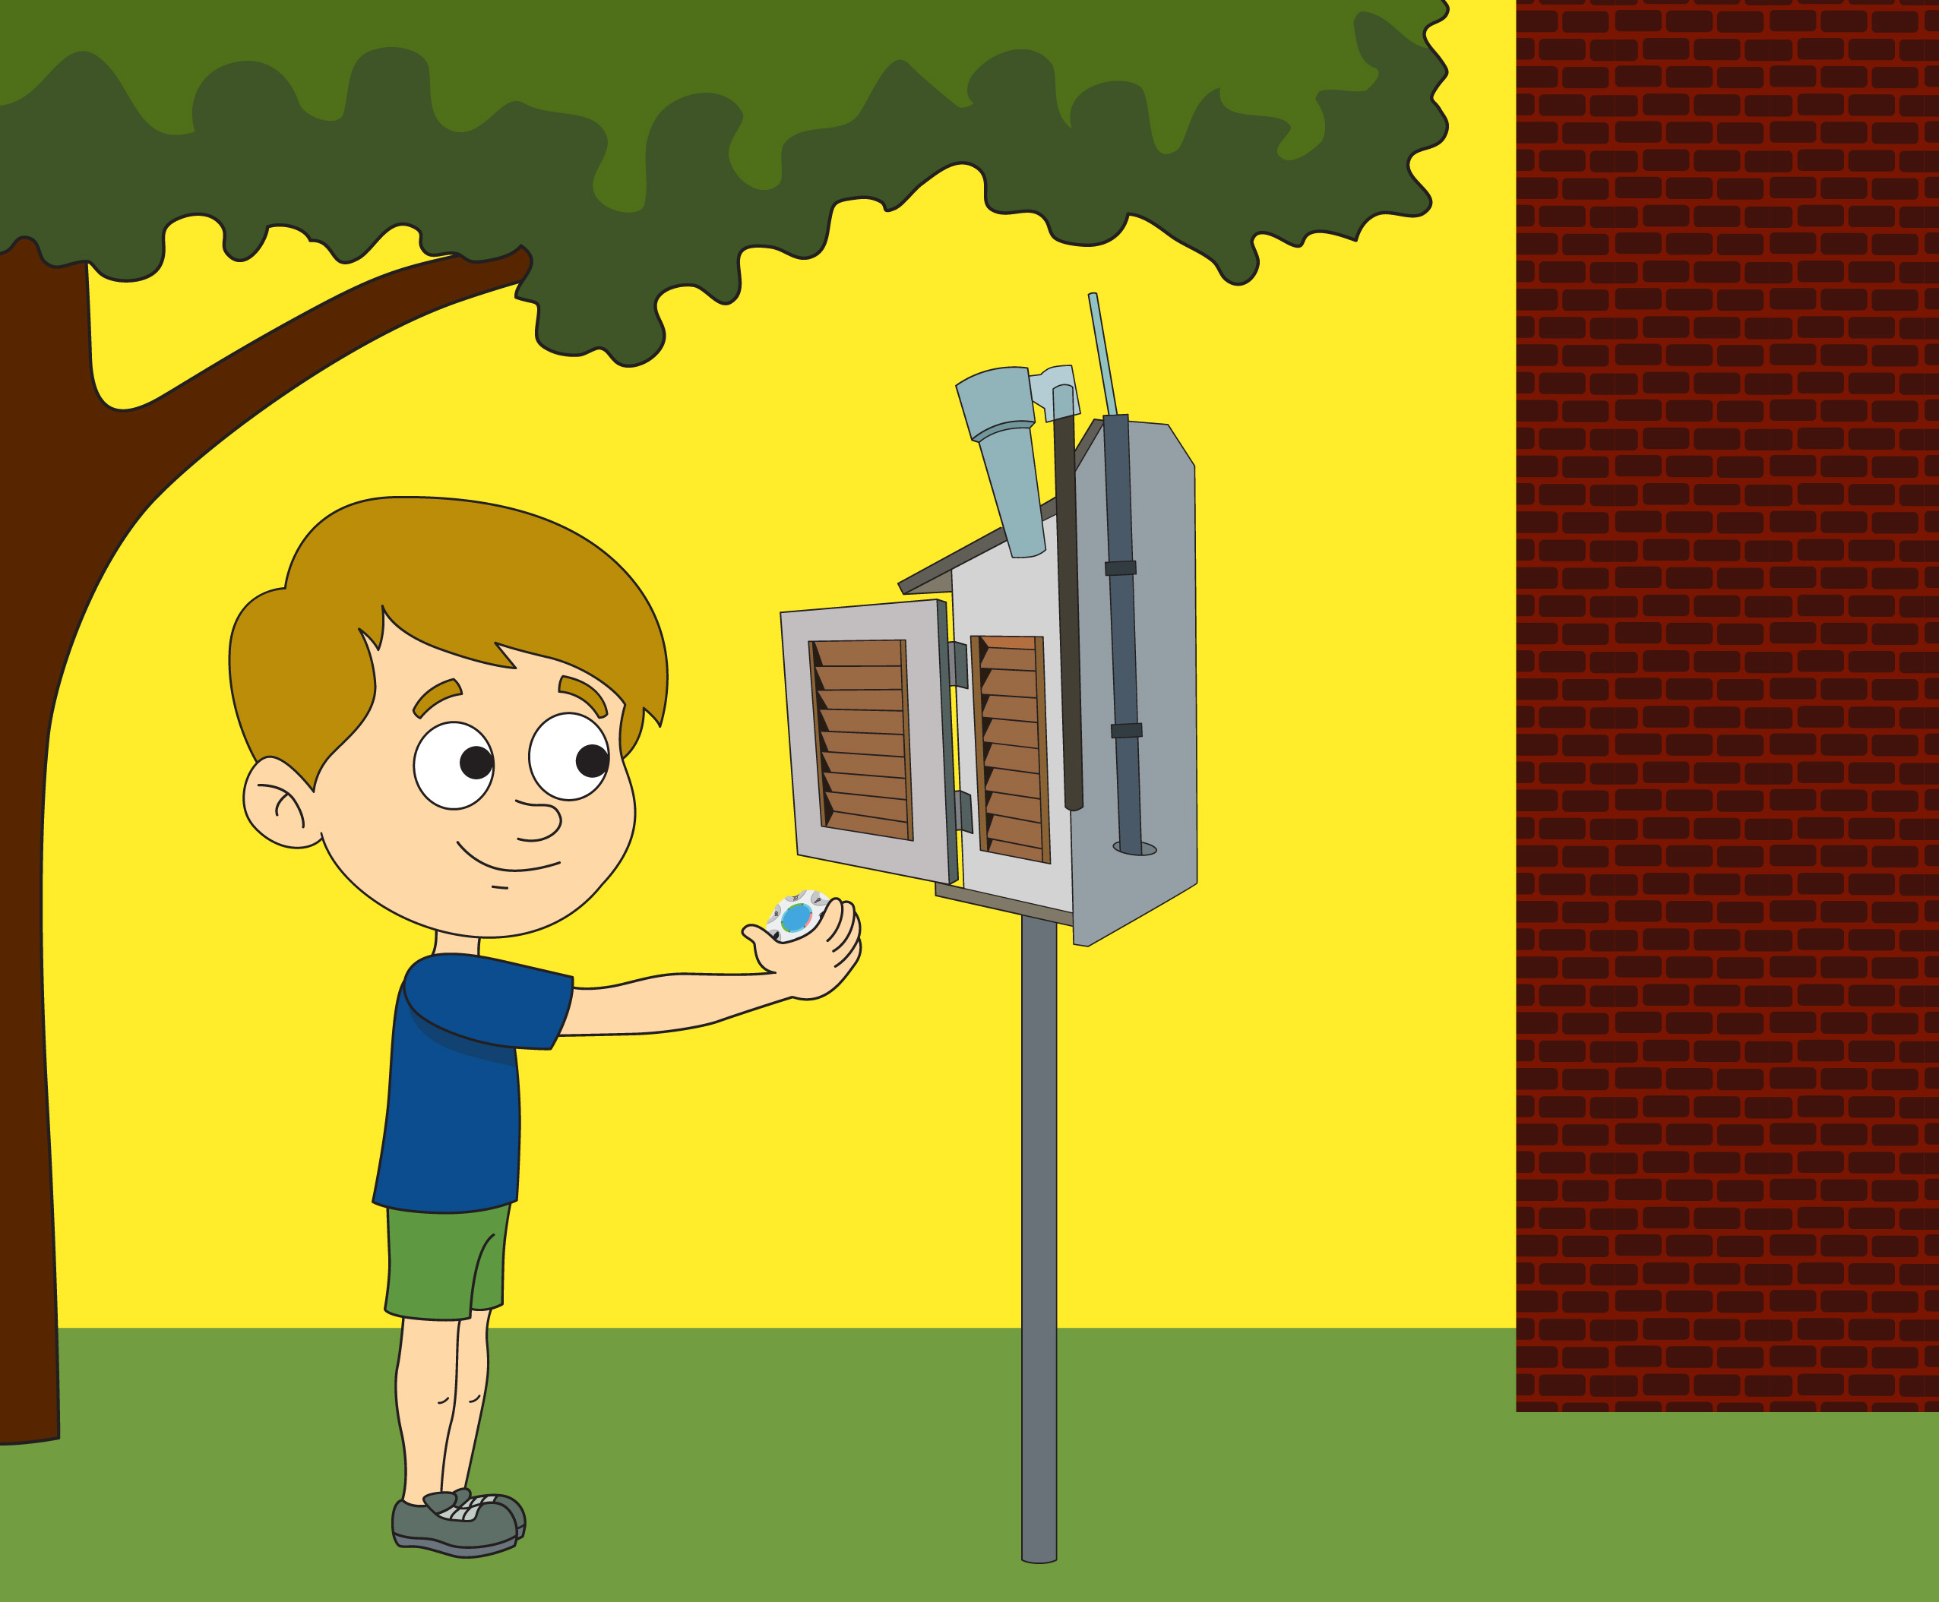

Experiment Procedure
Start the GlobiLab software from the computer/tablet and place the Mini in the weather station box.
- Allow the Mini to sit in the weather station for at least 30 minutes before taking your first measurement. To take a measurement, simply press the blue control key in the center of the Mini. Return the Mini to the weather station and close the door.
- At this time, also start recording the daily weather conditions. Pick three times during the day to post the current weather conditions with a symbol on the Weather Data bulletin board. Be sure to take a measurement with the Mini at these same times. Collect this data at the same time every day.
- Be sure to check and empty your rain gauge daily and make a note of the amount of precipitation collected. Save this information you will use it at the end of the activity. Be sure to do check your rain gauge at the same time each day – starting 24 hours after you set up your weather logging station.
- At the end of the week, collect the Mini from the weather station box and connect it to the GlobiLab software. Download and save the data with the week’s date. Clear the Mini’s memory and return the Mini to the weather station box.
- Project the GlobiLab graph so that all students can see a line graph of all of the data collected during the week. Label each collection point with day and time of the data collection. Your graph will look something like this:
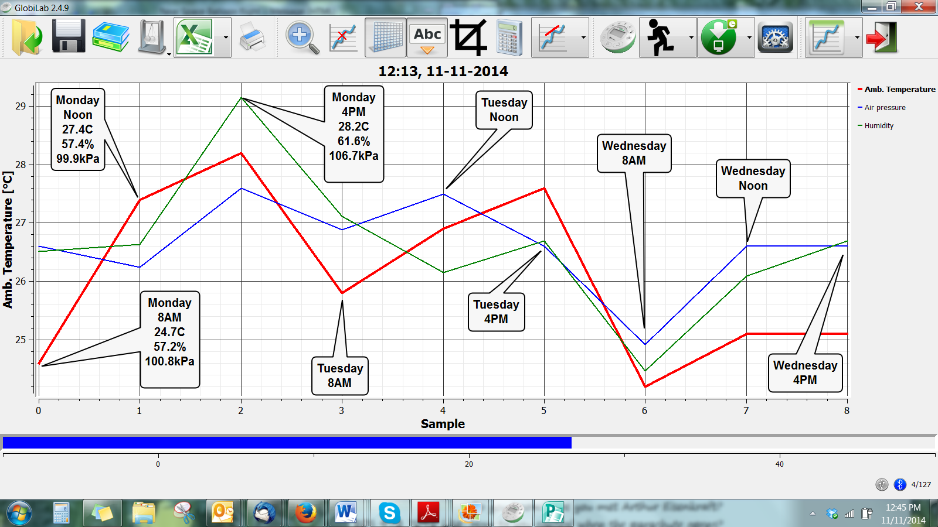
- Identify where the graph shows higher temperatures and where it shows lower temperatures.
- Mark the temperatures on both the class weather graph and individual student weather graphs.
- Repeat steps 6 and 7 with the humidity measurements.
- Repeat steps 6 and 7 with air pressure measurements.
- After answering the questions below, take a picture of the week’s graph so that you can compare your information with information from other weeks and other schools.
Questions & Observations
- During what time of day were the temperatures the highest? The lowest?
- What happened to the temperatures between morning and lunch? Between lunch and the end of the day? What do you think happened at dinner time? At bed time?
- Look at the week’s weather graph. Are there places where the graph bars do not change where you thought they would? What could have caused these changes? What kind of weather conditions were happening at the time of the change?
- What kind of weather makes temperature warmer? What kind of weather makes temperatures cooler?
- Did you observe any predictable patterns in the humidity measurements? If so, what?
- Did you observe any link between the humidity level and the local weather conditions? If so what did you see?
- Did you observe any predictable patterns in the air pressure measurements? If so, what?
- Did you observe any link between the air pressure and the local weather conditions? If so what did you see?

NGSS Standards
Performance Expectations
Represent data in tables and graphical displays to describe typical weather conditions expected during a particular season. 3-ESS2-1

Science and Engineering Practices
Represent data in tables and various graphical displays (bar graphs and pictographs) to reveal patterns that indicate relationships.

Disciplinary Core Ideas
ESS2.D: Weather and Climate
Scientists record patterns of the weather across different times and areas so that they can make predictions about what kind of weather might happen next.

Crosscutting Concepts
Patterns of change can be used to make predictions.

Common Core State Standards Connections

ELA/Literacy
- RI.3.1 - With prompting and support, ask and answer questions about key details in a text.
- W.3.1 - Write opinion pieces on topics or texts, supporting a point of view with reasons.

Mathematics
- 3.MD.B.3 - Draw a scaled picture graph and a scaled bar graph to represent a data set with several categories. Solve one- and two-step "how many more" and "how many less" problems using information presented in scaled bar graphs.
- MP.2 - Reason abstractly and quantitatively.
- MP.5 - Use appropriate tools strategically.

Weather Calendar
Monday | Tuesday | Wednesday | Thursday | Friday

