Turn Down the Noise
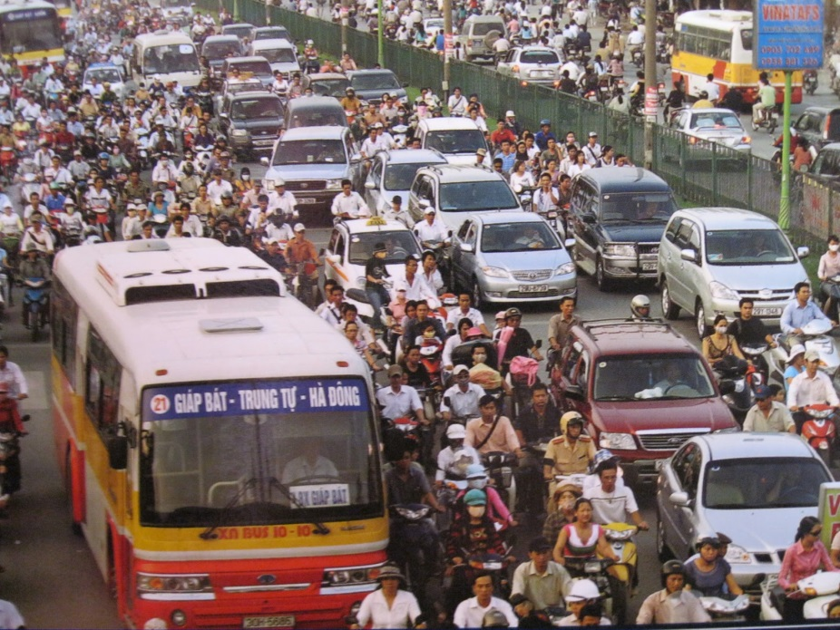
Noise pollution or noise disturbance is disturbing or excessive noise that may harm the activity or balance of human or animal life. The source of most outdoor noise worldwide is mainly caused by machines and transportation systems, motor vehicles, aircraft, and trains.
Noise health effects are the health consequences of elevated sound levels. Elevated workplace or other noise can cause hearing impairment, hypertension, heart disease, annoyance, and sleep disturbance. Changes in the immune system and birth defects have been attributed to noise exposure. The most significant causes are vehicle and aircraft noise, prolonged exposure to loud music, and industrial noise. In some places, road traffic has been demonstrated to cause almost 80% of the noise annoyances reported.
With the Labdisc, students have the opportunity to measure the impact of noise pollution in their community and to share this information with community leaders to help make their school and community a better and healthier place.
What to Do
Use the Labdisc to collect information about noise and to provide feedback to your local government about noise near your school. For all three data collections, set up the Labdisc to record sound. Set the sample rate for 1/second and the sample size for 10000.
1. Take a walk in the neighborhoods/communities around the school. Be sure to carry the Labdisc in your hands and to not talk during your walk. Take notes of the things/activities that you hear making noticeable noise. Repeat the same walk at different times of the day; early morning, mid-day, late afternoon & rush hour (end of work day drive time).
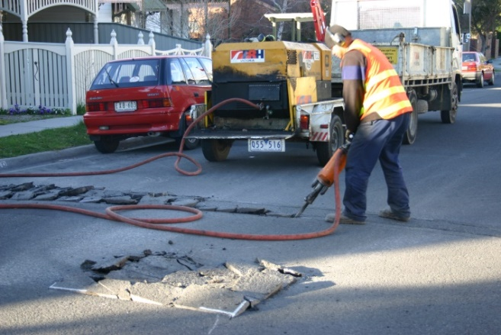
When you return to the classroom, download your data collection into the Globilab software. Save it with a day and time. Display the data as a line graph. Use the Annotation tool to label what was causing noise at various points in your data collection. Then change the display to show the Google map display. Your sound data and the walk that you took will show on the map. Compare the sound levels at various locations at different times of day.
2. Place the Labdisc in the area where you recorded the highest noise level in your previous sample collection. Start the Labdisc and let it collect data for at least a 24 hour period on one location. It may be worthwhile to collect data on both a week day and a weekend day. Make sure that your Labdisc is protected from the weather and from theft.
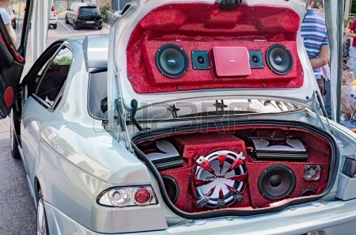
3. Take a Labdisc home with you. Walk around your neighborhood and collect sound data at different times of the day; early morning, mid-day, late afternoon and rush hour (end of work day drive time).
When you return to the classroom, download your data collection into the Globilab software. Display it as a bar graph. Use the Annotation tool to label where you took your samples and at what time the samples were taken. Include the photos that you took as part of your labels. Compare the sound levels in each spot at different times of day. Compare the sound levels from different neighborhoods where students live.
If you need assistance setting up the Labdisc, please refer to
Getting to Know the Labdisc for detailed instructions.
Ask Yourself
- How loud was the loudest noise that you recorded?
- Where was that location? What was making the noise?
- Was the noise loud enough to be disruptive to human activity? Was the noise loud enough to be dangerous to people’s hearing?
- What could be done to make this area more people friendly?
- Which areas were always loud during your recordings?
- Which areas had a great deal of change in noise level? What times of day were quieter? What times of day had more noise? Why
- Were the noisy times loud enough to be disruptive to human activity?
- What could be done to make this area more people friendly?
- What kinds of noise levels did you find in the neighborhoods where students live?
- How did the noise levels at home compare to the noise levels near the school?
- Did they type of residence affect the noise level (i.e. house vs apartment, etc.) outside the residence? Inside the residence?

Now What?
- Design/develop a solution to reduce the noise in the areas where the noise level was disruptive or dangerous to human activity.
- Develop a poster or a PowerPoint presentation to share this information.
- Share the presentation with…. Your class…. Your principal….. Your local government (i.e. Mayor or City Council).

