The Sun’s Effects
Introduction
Heating the Earth

Sunlight carries energy, which warms up the Earth and is the driving force behind all our weather and climate. Energy from the Sun is transferred through space and through the Earth's atmosphere to the Earth's surface. Since this energy warms the Earth's surface and atmosphere, some of it is or becomes heat energy. There are three ways heat is transferred into and through the atmosphere:
- Radiation
- Conduction
- Convection
Radiation
If you have stood in front of a fireplace or near a campfire, you have felt the heat transfer known as radiation. The side of your body that is nearest the fire gets warm, while your other side remains unaffected by the heat. Although you are surrounded by air, the air has nothing to do with this transfer of heat. Radiation is the transfer of heat energy through space by electromagnetic radiation.
Most of the electromagnetic radiation from the Sun is in the form of visible light. Light is made of waves of different frequencies. Our brains interpret the different frequencies into colors, including red, orange, yellow, green, blue, indigo, and violet. When the eye views all these different colors at the same time, it is interpreted as white. Waves from the sun which we cannot see are infrared, which have lower frequencies than red, and ultraviolet, which have higher frequencies than violet light.
Most of the solar radiation is absorbed by the atmosphere and much of what reaches the Earth's surface is radiated back into the atmosphere to become heat energy. Dark colored objects such as asphalt absorb more of the radiant energy and warm faster that light colored objects. Dark objects also radiate their energy faster than lighter colored objects.
Conduction
Conduction is the transfer of heat energy from one substance to another or within a substance. A metal spoon in a pot of soup being heated on a stove will become hot. This is due to transfer of heat energy from molecule to molecule or from atom to atom. This is called conduction and is a very effective method of heat transfer in metals. However, air conducts heat poorly.
Convection
Convection is the transfer of heat energy in a fluid. This type of heating what you see in the kitchen when you see liquid boiling. Air in the atmosphere acts like a fluid. The sun's radiation hits the ground, warming the ground. As the rock's temperature rises due to conduction, heat energy is released into the atmosphere, forming a bubble of air which is warmer than the surrounding air. This bubble of air rises into the atmosphere. As it rises, the bubble cools with the heat contained in the bubble moving into the atmosphere.
As the hot air mass rises, the air is replaced by the surrounding cooler, denser air, what we feel as wind. These movements of air masses can be small in a certain region, such as local cumulus clouds, or large cycles in the troposphere, covering large sections of the earth. Convection currents are responsible for many weather patterns in the troposphere.
Materials needed
- Mini with External Temperature sensor
- Digital camera or cell phone/tablet with camera
- 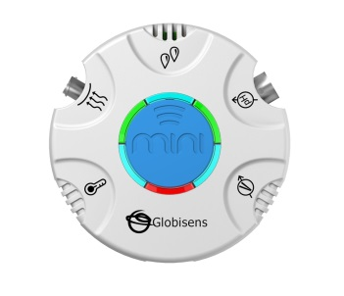Cardboard box, newspaper, pipe cleaners, pillowcase, tent, umbrella - items that can be used to shelter the Mini.
Mini Set Up
For this experiment you will setup the Mini from the GlobiLab software. Use the directions in Getting to Know the Mini if you need assistance.
- Sensor Selection - select External Temperature
- Sampling Rate - Manual
- Number of Samples - select 10

When you push the Run button, the green LED lights will circle, indicating that the Mini is in Manual data collection mode.
Experiment Procedure: Part I
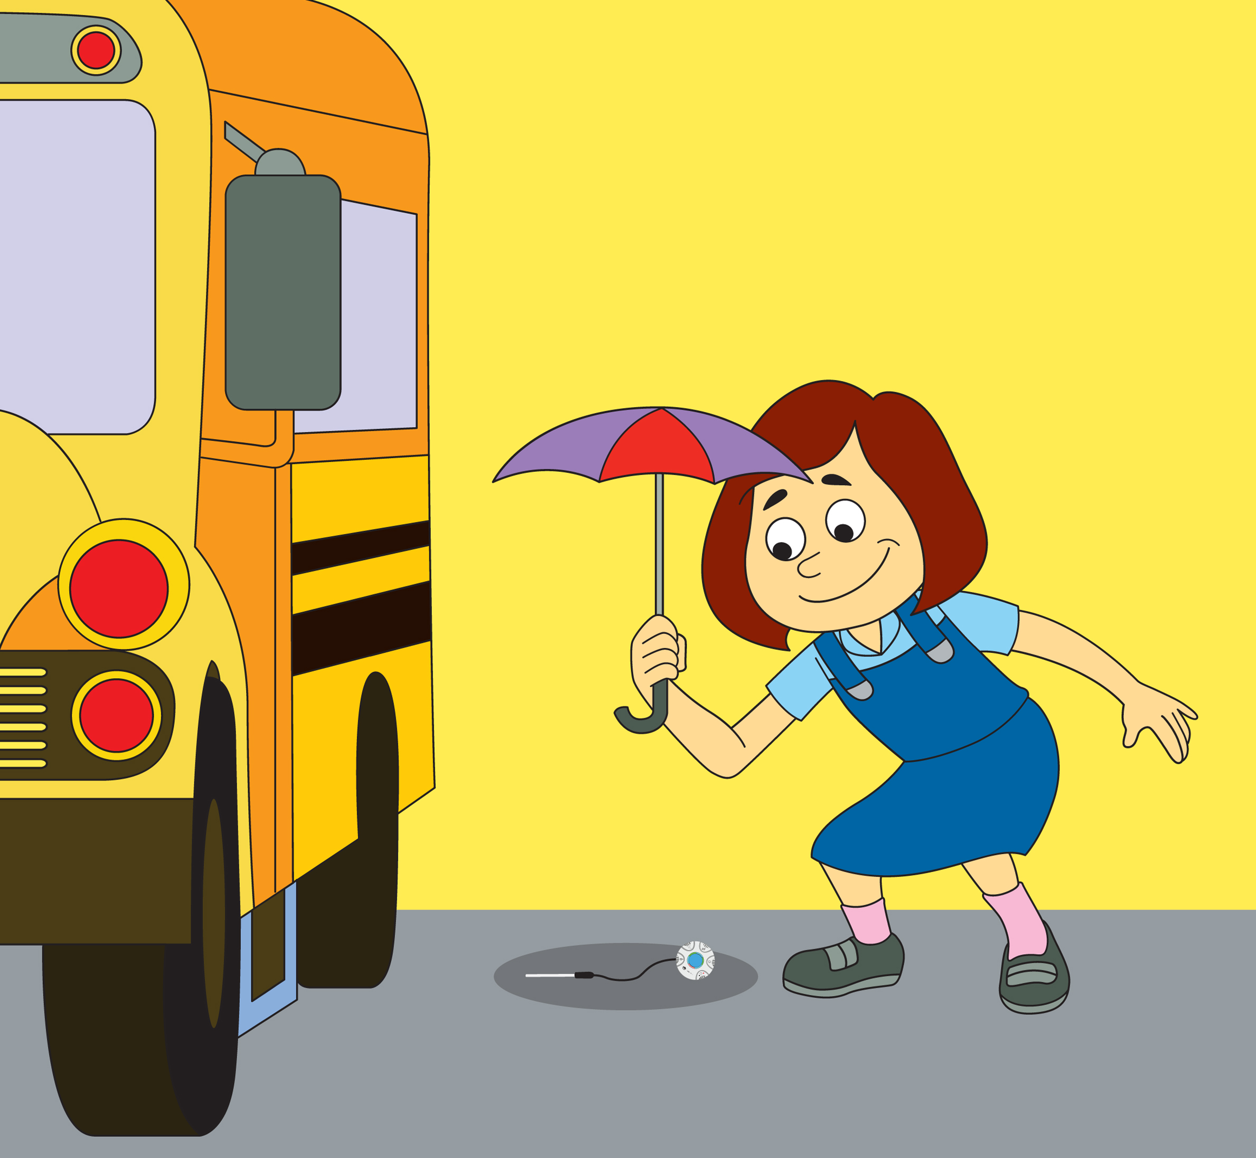
- Using the External Temperature sensor, measure the temperatures of a 10 different locations around the school yard. These should include areas in sunlight and shadow as well as areas with different geologic make-up like soil, grass, sand, water, asphalt, etc. Touch the tip of the temperature probe to the substrate where the temperature is to being measured. Allow the External Temperature sensor to rest in each location for 30 seconds before you measure the temperature by pressing the blue control key in the center of the Mini.
- Take a photo of the Mini in each location.
- Connect the Mini to the GlobiLab software and save your data collection. Project the data in a bar graph format so that all students can see the temperatures collected. Label each bar with location of the data collection and the temperature. Add a photo of each location. Your graph will look something like this:
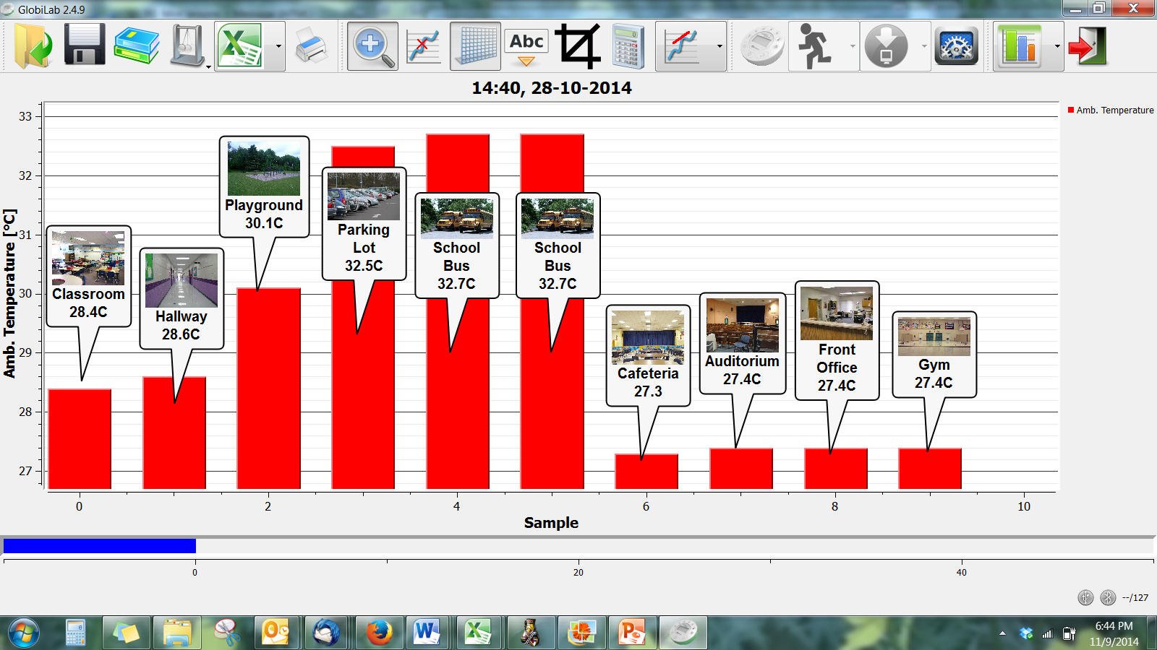
Questions & Observations
- Discuss which areas are warmer or cooler than others. Ask students to explain why they think this is so. Using a Socratic Method guide the discussion towards students realizing that areas in shade and lighter colored areas have lower temperatures.
- Ask students to brainstorm how they might create cooler temperatures in an area.

Experiment Procedure: Part II
- Using light and dark colored paper/fabric and other materials, have students create small structures/tents that can be used to cover the areas where temperatures were taken. Have them experiment with different sizes and configurations (i.e. sides, no sides, dark vs light colors).
- Start this data collection from the GlobiLab software and repeat the temperature measurements in the same locations where the Mini projected the first “tent”.
- Using the GlobiLab software, create a graph showing your results. Label where measurements were taken and include a photo of the structure used for cover at each location.
- Compare the temperature in each location before and after the “tent” was put in place.
Questions & Observations
- What changes did providing shelter create in the areas where the temperatures were measured? How did these changes affect the temperature?
- Which structures were the most effective in lowering the temperature? Did size make any difference? Did color make any difference? Were structures that were open sided more or less effective in lowering temperatures?
Extensions
Place the External Temperature sensor inside clothing items of different colors and place them in the sun and shade and record temperature measurements. Have students predict which colors will heat up more quickly and to higher temperatures.

Next Generation Science Standards

Performance Expectations
- Make observations to determine the effect of sunlight on Earth’s surface. K-PS3-1
- Use tools and materials provided to design and build a structure that will reduce the warming effect of sunlight on an area. K-PS3-2

Science & Engineering Practices
- Ask questions based on observations to find more information about the designed world.
- Make observations (firsthand or from media) to collect data that can be used to make comparisons.
- Use observations (firsthand or from media) to describe patterns in the natural world in order to answer scientific questions.
- Scientists look for patterns and order when making observations about the world.
- Scientists use different ways to study the world.

Disciplinary Core Ideas
Sunlight warms the Earth’s surface

Crosscutting Concepts
Events have causes that generate observable patterns.

Common Core State Standards Connections

ELA/Literacy
- SL.K.3 - Ask and answer questions in order to seek help, get information, or clarify something that is not understood.
- W.K.7 - Participate in shared research and writing projects.

Mathematics
- K.CC - Counting and Cardinality
- K.CC.A - Know number names and the count sequence.
- K.MD.A.1 - Describe measurable attributes of objects, such as length or weight. Describe several measurable attributes of a single object.
- K.MD.A.2 - Directly compare two objects with a measurable attribute in common, to see which object has "more of"/"less of" the attribute, and describe the difference.

