Temperatures Around Us
Introduction
Have students look at pictures of different climates and describe the temperature in each picture. Ask them to explain why they think so. Ask what it’s like to be hot, cold, and cool. Is it possible for one person to be hot and another person cold at the same time/same place? Why? What temperature is hot? Cool? Cold? Name some places around the school that are hot, cool or cold.
Accurate measurements are an important part of science. Many different aspects of objects are measured – temperature, weight/mass and length are some of the most common. We measure temperature to have an actual measurement of how hot or cold something or somewhere is rather than an opinion.
Measurements to be taken
In this investigation, students will measure environmental temperatures from a variety of locations around the school.
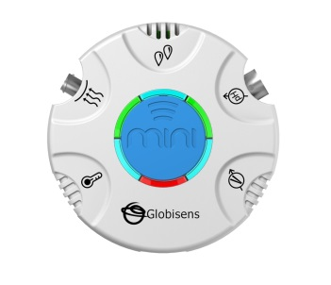Materials needed
Mini with an External Temperature probe.

Mini Set Up
For this experiment you will setup the Mini from the GlobiLab software menu. Use the directions in Getting to Know the Mini if you need assistance in setting up the Mini through the GlobiLab software.
- Sensor Selection - select Ambient Temperature & GPS
- Sampling Rate - Manual
- Number of Samples - select 10
Push the Run button and the green LED lights will circle, indicating that the Mini is in Manual data collection mode.
Experiment Set Up
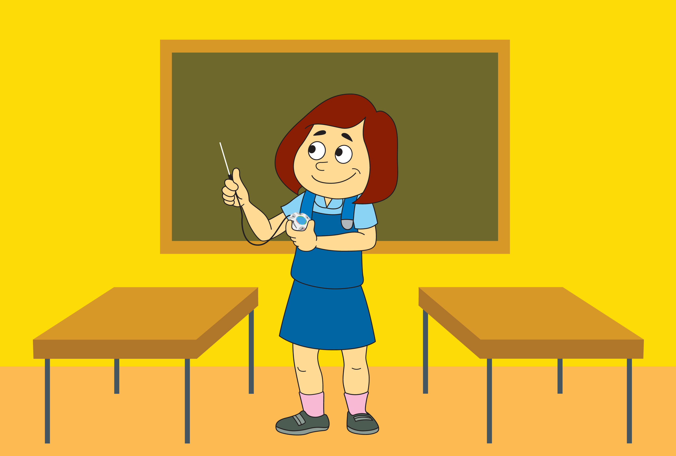 No advance preparation is needed.

Experiment Procedure
- Introduce the Mini and External Temperature sensor. Explain that when taking a temperature measurement, that it is important to wait about 30 seconds for the temperature to stabilize before moving to the next temperature reading.
- Start the data collection from the GlobiLab software. Make sure that students do not have their hands on the metal part of the temperature probe. When you are ready, press the blue center control key to record a measurement.
- Have students measure the following:
  - Temperature in the classroom
  - Temperature right outside the room
  - Temperature on the playground
  - Temperature in the parking lot
  - Temperature for six other places around the school

- Open the GlobiLab software and connect the Mini to the computer through the wireless Bluetooth channel. Click on the download icon to transfer the last recording from the Mini memory to the software.
- Use the Annotation tool to label each measurement with the temperature and a picture of the location. You can use the Table view to get an exact temperature reading. Your graph will look something like this:
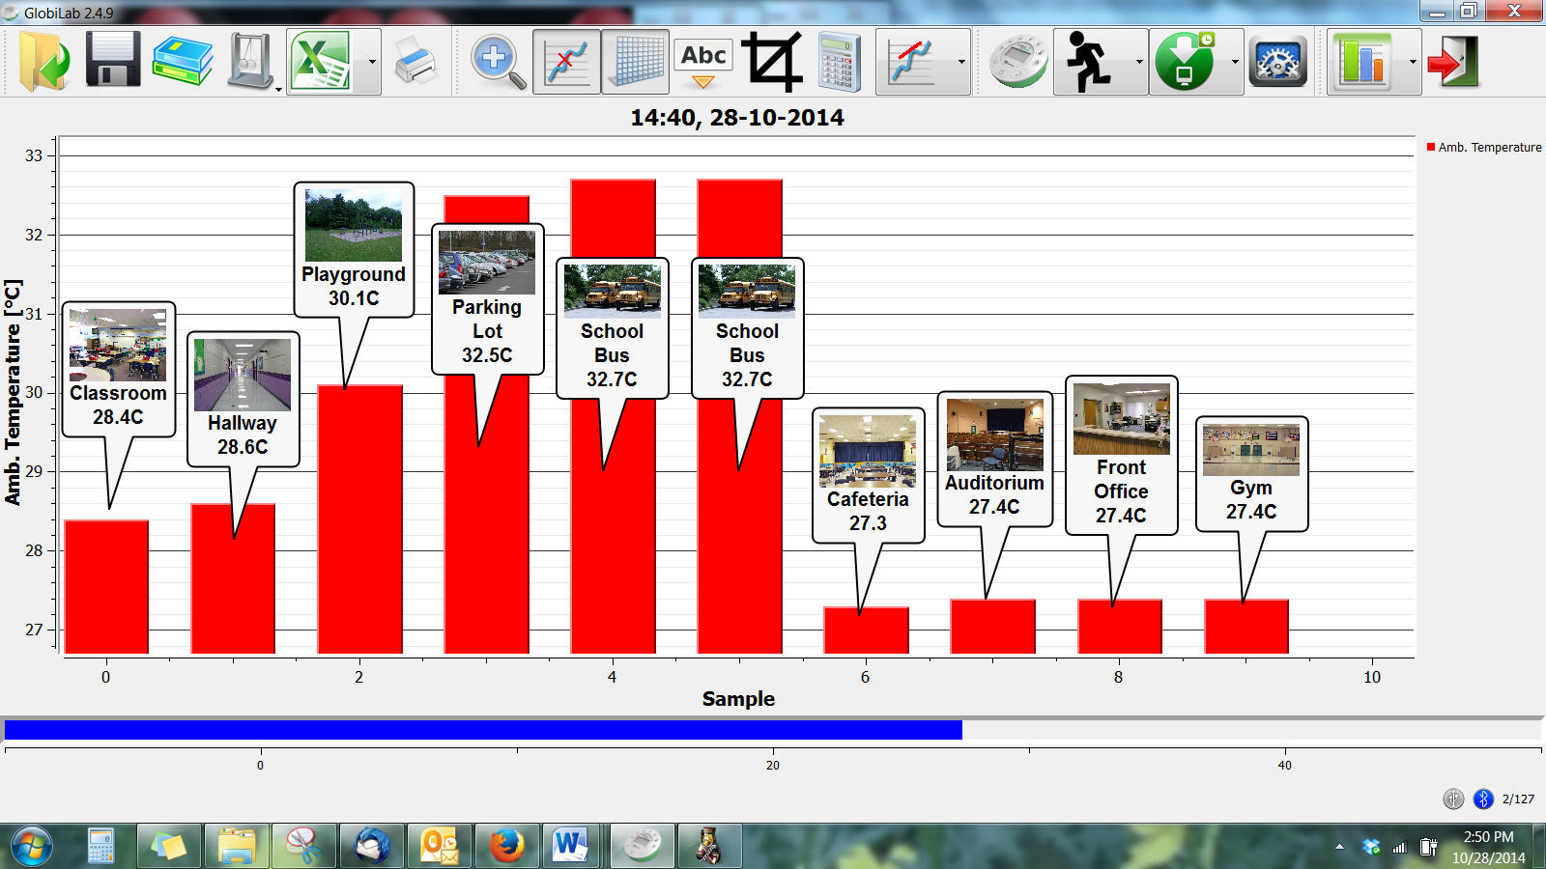
- Switch to the Map View and look at the areas where the temperatures were recorded on a map.
- Save your project by clicking on the SAVE icon.
Questions & Observations
Ask students to answer the questions below using their collected data.

- What was the temperature of the classroom?
- What was temperature right outside the classroom?
- What was temperature on the playground?
- What was temperature in the parking lot?
- Where else did you measure? What was the temperature?
- Why is it important to know the temperature of an area?
- Why is it important for measurements to be accurate?
- Where were the highest temperatures found? Would you call these areas hot? Why do you think the temperatures were higher in these areas?
- Where were the lowest temperatures found? Would you call these areas cool or cold? Why do you think the temperatures were lower in these areas?
Extension Activity
- Use a digital camera/tablet/smartphone to take photos of the areas where you took temperature readings and add them to your graph display.
- Choose additional items to measure (i.e. beverages, food, etc.) and try to predict/guess their temperature. Measure them and see how accurate your predictions are.

Next Generation Science Standards

Performance Expectations
- Make observations to determine the effect of sunlight on Earth’s surface. K-PS3-1
- Use tools and materials provided to design and build a structure that will reduce the warming effect of sunlight on an area. K-PS3-2

Science & Engineering Practices
- Ask questions based on observations to find more information about the designed world.
- Make observations (firsthand or from media) to collect data that can be used to make comparisons.
- Use observations (firsthand or from media) to describe patterns in the natural world in order to answer scientific questions.
- Scientists look for patterns and order when making observations about the world.
- Scientists use different ways to study the world.

Disciplinary Core Ideas
Sunlight warms the Earth’s surface.

Crosscutting Concepts
Events have causes that generate observable patterns

Common Core State Standards Connections

ELA/Literacy
- SL.K.3 - Ask and answer questions in order to seek help, get information, or clarify something that is not understood.
- W.K.7 - Participate in shared research and writing projects.

Mathematics
- K.CC - Counting and Cardinality
- K.CC.A - Know number names and the count sequence.
- K.MD.A.1 - Describe measurable attributes of objects, such as length or weight. Describe several measurable attributes of a single object.
- K.MD.A.2 - Directly compare two objects with a measurable attribute in common, to see which object has "more of"/"less of" the attribute, and describe the difference.

