Sources of Heat and Light Other than the Sun
Introduction
One way to create heat is to use mechanical energy. Mechanical heat is created by anything that moves or runs without a battery or electricity. An object’s movement creates mechanical heat. When two surfaces are rubbed against each other, the friction between the two surfaces can be experienced as heat. Even soft or squishy surfaces generate friction, as the surfaces bend around each other in tiny curves and get in the way of each other.
Friction is the force resisting the relative motion of solid surfaces, fluid layers, and material elements sliding against each other. When surfaces in contact move relative to each other, the friction between the two surfaces converts kinetic energy into thermal energy. This can have dramatic consequences like using friction created by rubbing pieces of wood together to start a fire. Kinetic energy is converted to thermal energy whenever motion with friction occurs, for example when an ice skate slides across the rink.
When surfaces resist sliding past each other, they move more slowly than they would otherwise. Energy is equal to mass multiplied by velocity, and when the velocity (the speed of the surfaces sliding past each other) is reduced without changing the mass of the objects, some energy must be released to keep the balance. The released energy is what we feel as heat!
Electrical machines need electricity and usually plug into an electrical outlet or use batteries. Electrical energy can be a source of heat and light. A light bulb is an example of a simple electrical machine. It has no moving parts. There are many different types of light bulbs. Some light bulbs get hot and are a heat source. You can use the temperature sensor to measure the amount of heat given off by a light bulb.
Some light bulbs are energy efficient. Energy efficient bulbs emit light, but lose very little heat, so they are not a heat source. Energy efficient bulbs are good for the environment because they last longer and use less energy to produce light. This lesson will help students figure out which light bulbs are energy efficient.
Measurements to be taken
In this investigation, students will measure heat created by mechanical and electrical sources.
Objectives - Students will be able to:
- Demonstrate that mechanical and electrical machines produce heat and sometimes light.
- Identify and classify mechanical and electrical sources of heat.
- List examples of mechanical or electrical devices that produce light.
- Predict, measure, and graph the temperature changes produced by a variety of mechanical machines and electrical devices while they are operating.
Materials needed
- Mini with External Temperature sensor
- Hand lotion
- Lamp with Incandescent light bulb
- Lamp with Compact Fluorescent (CLF) light bulb
- Lamp with LED light bulb
- Student worksheet (attached)
Mini Set Up
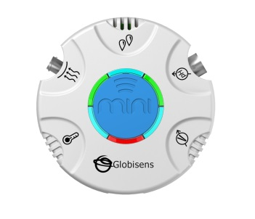For this experiment you will setup the Labdisc Mini from the Labdisc menu. Use the directions in Getting to Know The Labdisc Mini if you need assistance in setting up the Labdisc through the GlobiLab software.
- Sensor Selection - select the External Temperature.
- Sampling Rate - 10/second
- Number of Samples – select 1,000

When you begin the data collection, the green LED lights will circle, and then pause for about 3 seconds at the external temperature sensor indicating that the temperature sensor is “live.”
Experiment Set Up
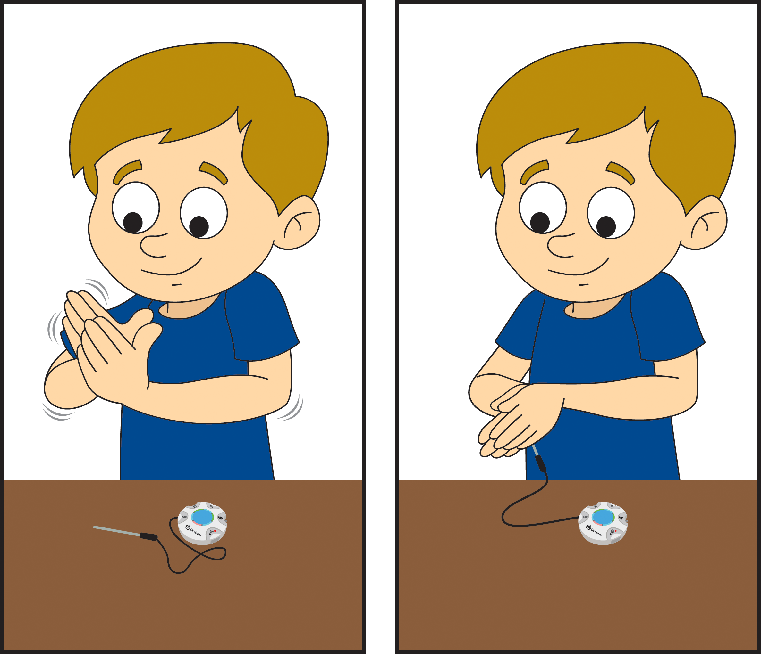

Part 1
Plug the External Temperature sensor into the Mini.
Part 2
Plug in the lamps so that students will not trip over the cords. Make sure that students understand not to touch the light bulbs. Turn them on when you are starting Part 1.
Experiment Procedure
Part 1
- Have students put their hands to the sides of their face so that the palms are flat on their cheeks. Describe how the hands feel against their cheeks.
- Place the External Temperature sensor between the palms of the hands. Start the data collection using the Run button and hold the Temperature sensor still between flat palms.
- Have them quickly rub their hands together, palms flat for 20 seconds and place hands on their cheeks again. Describe how the hands feel against the cheeks after rubbing.
- Place the External Temperature sensor between the palms of the hands again but start the next data collection using the Run+ button. The Run+ button will create an overlay of the second data collection over the first so that they can easily be compared. Your graph will look something like this:
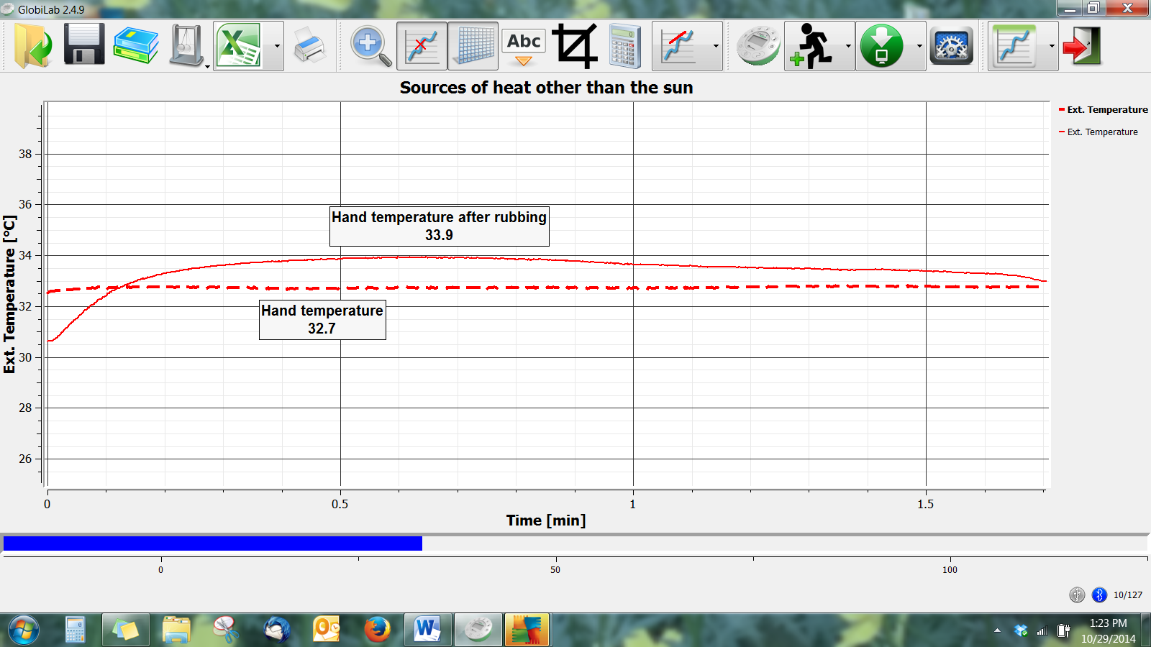
Part 2
- Hold the External Temperature sensor approximately 1” away from the incandescent light bulb to measure the temperature. Start the data collection using the Run button.
- Hold the External Temperature sensor approximately 1” away from the incandescent light bulb to measure the temperature. Start the data collection using Run+ button.
- Save your data as Incandescent vs CFL – 1”
- Hold the External Temperature sensor approximately 1” away from the LED light bulb to measure the temperature. Start the data collection using Run+ button.
- Save your data as CFL vs LED - 1”.
- Repeat steps 2, 3 & 4 with distances of 6” and 12”. Be sure to save your data with a label indicating the type of bulb and distances observed.
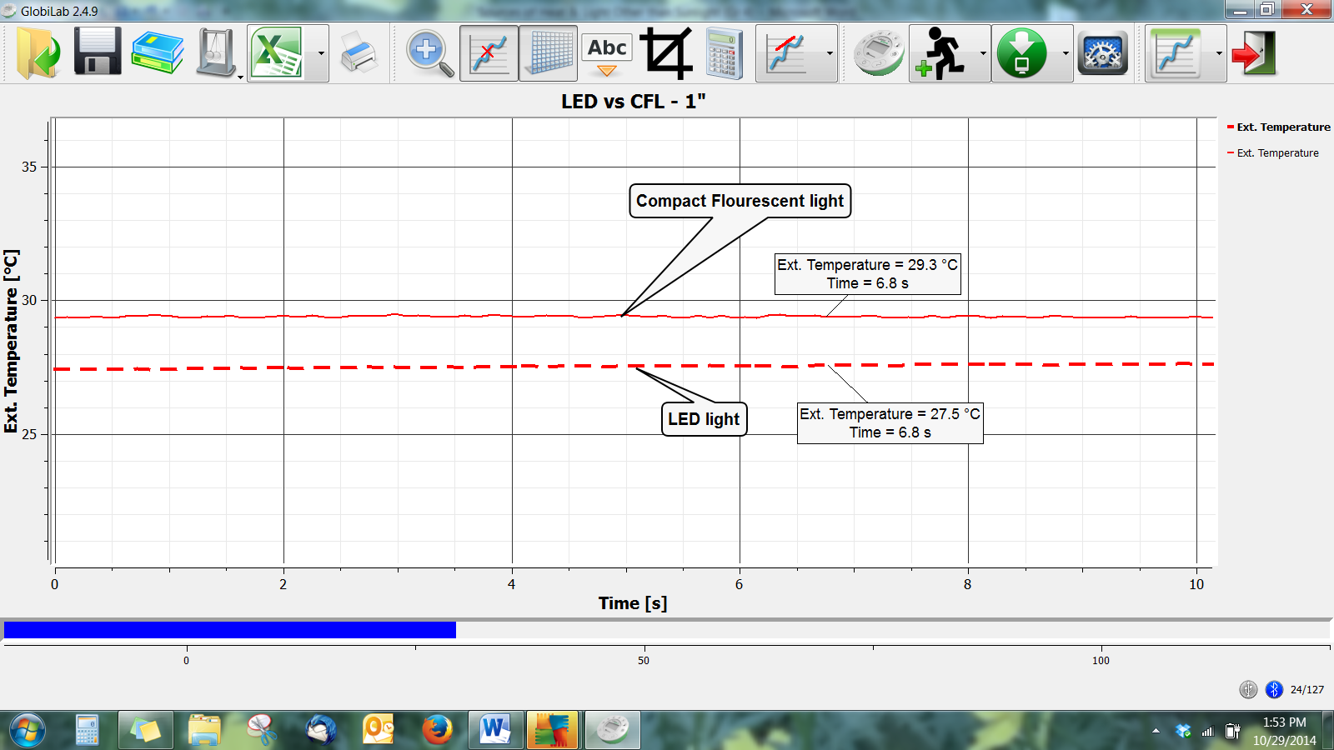
Questions & Observations
Part 1
- Have students describe the temperature of their hands before rubbing. i.e. warm, cool….
- Have them describe the temperature of their hands after rubbing. i.e. warm, cool….
- What was the actual temperature of your palms? What was the temperature after rubbing your hands together?
- Where does this heat come from?
- Define friction in your own words.
Part 2
- Was there a difference in the amount of heat produced by each type of light bulb at 1”? At 6”? At 12”?
- Which type of light bulb produces the smallest amount of heat at 1”? At 6”? At 12”?
- Where did this heat come from?
- Which type of light bulb do you believe is the most energy efficient? Why?
Extensions
- Will there be more heat if the hands were lubricated (made slippery) with lotion? Repeat Part 1 with hand lotion and see.
- Repeat Part 2 and measure the heat emitted by additional types of light bulbs like colored light bulbs, floodlights, etc. Compare this to your initial discoveries.
Sources of Heat and Light Other than the Sun Data Sheet
Hand Temperature
Before rubbing
After rubbing

- Describe the temperature of your hands before rubbing. i.e. warm, cool….
- Describe the temperature of your hands after rubbing. i.e. warm, cool….
- What was the actual temperature of your palms?
- What was the temperature after rubbing your hands together?
- Where did this heat come from?
- Define friction in your own words.
Bulb Type | Temperature at 1” | Temperature at 6” | Temperature at 12”
Incandescent
Compact Fluorescent
LED

- Was there a difference in the amount of heat produced by each type of light bulb at 1”? At 6”? At 12”?
- Which type of light bulb produces the smallest amount of heat at 1”? At 6”? At 12”?
- Where did this heat come from?
- Which type of light bulb do you believe is the most energy efficient? Why?
Next Generation Science Standards

Performance Expectations
Make observations to provide evidence that energy can be transferred from place to place by sound, light, heat, and electric currents. 4-PS3-2.

Science and Engineering Practices
Make observations to produce data to serve as the basis for evidence for an explanation of a phenomenon or test a design solution.

Disciplinary Core Ideas
- PS3.A: Definitions of Energy.
  - Energy can be moved from place to place by moving objects or through sound, light, or electric currents.
- PS3.B: Conservation of Energy and Energy Transfer
  - Energy is present whenever there are moving objects, sound, light, or heat. When objects collide, energy can be transferred from one object to another, thereby changing their motion. In such collisions, some energy is typically also transferred to the surrounding air; as a result, the air gets heated and sound is produced.
  - Light also transfers energy from place to place.
  - Energy can also be transferred from place to place by electric currents, which can then be used locally to produce motion, sound, heat, or light. The currents may have been produced to begin with by transforming the energy of motion into electrical energy.

Crosscutting Concepts
Energy can be transferred in various ways and between objects.

Common Core State Standards Connections

ELA/Literacy
- W.4.7 - Conduct short research projects that build knowledge through investigation of different aspects of a topic.
- W.4.8 - Recall relevant information from experiences or gather relevant information from print and digital sources; take notes and categorize information, and provide a list of sources.

