Project Nest Box
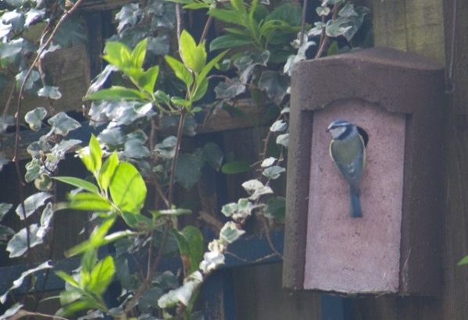
For many species of birds, there is a shortage of great places to nest. There may be birds that would love to call your habitat home, but they have a specific nesting requirement which needs to be met. Birdhouses can be placed in backyards, schoolyards, parks, orchards, farms, pastures, cemeteries, woodlots, deserts, cities...you name it. Support more nesting birds, and give a bird a home. Use these resources to become the ultimate nest box landlord; find out what features make a birdhouse ideal, which species you can attract to your area, and how to troubleshoot any problems that arise.
Participants in NestWatch, a citizen-science project of the Cornell Lab of Ornithology, monitor bird nests in their nest boxes (or any other place), gathering information such as the number of eggs or young in the nest. They then submit their data over the Internet to Lab scientists. Data gathered for NestWatch have been used in a great many studies, including ones examining effects of climate change on birds.
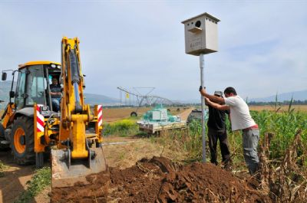
Another next box project, led by Professor Yossi-Leshem (world-recognized Ornithologist at Tel Aviv University’s Department of Zoology) and Dr. Motti Charter (Haifa University), measures the weather conditions of Falcon, Kestrel, Barn Owl and Great Tit bird boxes. This project hopes to demonstrate to local farmers the 24/7 pest control alternative provided by these bird species who eat rodents and reduce the need to spray crops. As part of this collaborative environmental research program, 8th to 12th grade students at the American International School in Israel and the Czech Republic participate in the GAIA (Global Awareness Investigation and Action) project. Light, humidity, internal and external temperatures are monitored and integrated with Google maps to indicate the most successful location and position for nesting.
Using this information, scientists travel around to farmers advising them about how to improve the effectiveness of nest boxes for the barn owls. Many farmers add boxes in location that are less suitable for barn owls. By suggesting better locations we are able to increase the number of barn owls using them and therefore decrease the total population of pests. For example, in the Hula Valley they assisted farmers to add 80 new nest boxes which were occupied 67.9% more than old boxes in the same area!
What to Do
For this project you should use an iPad or Android tablet with your Labdisc to minimize the number of times that you have to open the nesting box and so that you can download your data while in the field. If you are able to install a camera in the box you may also be able to observe the activity inside the box without opening it during the critical nesting periods. Otherwise, you will want to be sure to open the nest box as infrequently as possible to avoid disturbing the mother during the incubation process. Once hatching has occurred, try to wait until the parent birds have left the box to look inside.
For long term data collection inside the box, you will want to set the Labdisc with a sampling rate of 1/minute and a sample size of 10,000. This will allow your Labdisc to run for approximately 1 week without having to disturb the nesting box. You may want to consider collecting data on light, humidity and sound as well as temperature both inside and outside the nesting box.
If you are using a Mini, you will be able to collect data about humidity and both internal and external temperature (be sure there is a way that the External Temperature probe can be exposed without endangering the birds). Set the sample rate to 1/minute and the sample size to 3000.
1. Contact local conservation departments to learn more about any existing bird nesting box projects in your area to see if you can assist with data collection in existing bird nesting boxes. They will be able to explain to you the specific information that they would like for you to collect and help you make meaning of the information collected. Use the Labdisc to collect information about the conditions inside bird nesting boxes and look for correlations between nesting success and specific climatic conditions. Use this information to make recommendations for the location of additional next boxes or relocation of existing next boxes.
2. If you are unable to locate any on-going local bird nesting box projects, you can start one yourself. Again, your local conservation departments can help with recommendations for both which species to target and with suggested locations to create a local program to add nest boxes in your community to increase the population of beneficial avian wildlife.
3. Visit each nesting box on a weekly basis. Quickly and quietly remove the Labdisc from the nesting box and use the iPad or Android tablet to download the data from the time period. Restart the data collection and return the Labdisc to the nesting box.
If you are using a Mini, you will be able to stop the data collection and download the data without opening the nest box but your sample size will be limited by the Mini’s memory and so you will need to perform data downloads daily (do this at the same time every day).
If you need assistance setting up the Labdisc or Mini, please refer to Getting to Know the Labdisc or Getting to Know the Mini for detailed instructions.
Ask Yourself
- How many of your nest boxes had nests built in them?
- What species did you find using your nest boxes?
- Where they what you expected to find? If not, how do you explain this? Was it due to the physical nature of the nest box or the conditions in and around the nest box?
- How many of these nests successfully hatched offspring?
- What common conditions were observed in the areas where the successful nest boxes were located?
- Where there common conditions observed in the areas where the nest boxes were not successful?
- If you were to relocate the nest boxes that were not successful, what information from your data collection could be used to help ensure that they would be successful in their new locations?

Now What?
- Share your conclusions with…. Your class…. Your school…..Your community…. Your local conservation department.
- Make recommendations for locations of additional nest boxes or relocation of unsuccessful nest boxes.

Nest Box Resources
There are many resources with a great deal of information about bird nesting boxes. Some of them are listed below. Some of these are on-going data collection efforts about specific bird nesting box projects, while others are sources of plans or kits to build your own bird nesting boxes.

- http://www.cleanriver.com/project-nest-box
- http://www.cleanriver.com/project-nest-box-program-for-schools
- http://nc.audubon.org/creating-bird-friendly-communities-2
- http://nc.audubon.org/make-little-room-brown-headed-nuthatch
- http://www.birdboxisrael.org/About-Us.html
- http://www.gardenature.co.uk/side-view-bird-box-camera-system-ultra-hi-resolution
- http://www.wbais.net/page.cfm?p=534
- http://kingstonfieldnaturalists.org/bluebill/nestboxes.html
- http://www.allaboutbirds.org/page.aspx?pid=1139
- http://nestwatch.org/learn/all-about-birdhouses/
- http://wdfw.wa.gov/living/projects/index.html
- http://www.wildlifehc.org/new/wp-content/uploads/2010/10/Building-Nest-Boxes-Kits.pdf
- http://www.jjcardinal.com/houses.htm
- http://www.tucsonaudubon.org/what-we-do/urban/nestbox.html
- http://www.nysbs.org/handouts/BluebirdNestingBoxes.pdf

