Investigating Daily Weather
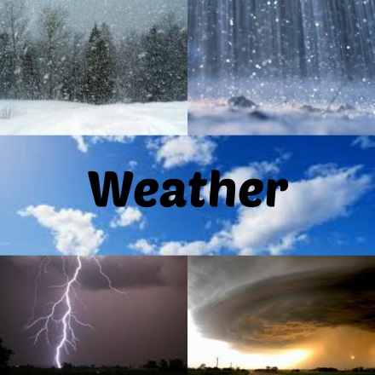
Many years ago, the only way of predicting the weather was to use local experiences. The next day’s weather was often predicted based on the previous day’s weather. As you can imagine, the success of such forecasting was not much better than making a random guess.
The science of weather forecasting is still developing. Weather prediction will never be perfect. Small changes in the weather in one place can cause much larger changes in weather elsewhere. The effects are small at first, but they become much greater. It’s very difficult for predict these interactions. Although forecasts will never be perfect, they will continue to improve in the years ahead. Through research, meteorologists learn more and more about the details of how weather in the Earth system works.
Once the national weather service began to gather weather observations from weather stations located over large areas of the country, simultaneous weather observations allowed meteorologists to plot weather maps and follow weather systems as they moved from place to place, greatly improving the accuracy of weather forecasts. Today even students can be part of the weather data collection network through the GLOBE Program.
The Global Learning and Observations to Benefit the Environment (GLOBE) program is a worldwide hands-on, primary and secondary school-based science and education program. GLOBE brings together students, teachers and scientists through the GLOBE Schools Network in support of student learning and research. Parents, Scientists and GLOBE Alumni also support students' engagement in GLOBE. GLOBE's vision promotes and supports students, teachers and scientists to collaborate on inquiry-based investigations of the environment and the Earth system working in close partnership with NASA, NOAA and NSF Earth System Science Projects (ESSP's) in study and research about the dynamics of Earth's environment.
What to Do
1. Build a student weather station at your school and use the Labdisc to collect ongoing data about the weather conditions in your area.
2. Select a place in your school yard that is shaded from the sun and at least 1 meter from any buildings. The protective box should be placed on a stand at least 60 cm tall (like a picnic table or an overturned trash can or a pole). You want to be sure that heat from the ground or buildings doesn’t interfere with your measurements. Attach your rain gauge to side of the protective box so that it does not interfere with opening the box and is not covered by any part of the box’s roof.
3. Set up the Labdisc to collect 1 sample/minute on the Ambient Temperature, Humidity and Barometric Pressure sensors. If you need assistance setting up the Labdisc, please refer to Getting to Know the Labdisc for detailed instructions.
4. Allow the Labdisc to run collecting data for one week. You should check and empty your rain gauge daily and make a note of the amount of precipitation collected. Save this information - you will use it at the end of the activity. Be sure to do this at the same time each day – starting 24 hours after you set up your weather logging station.
5. At this time, also start recording the daily weather conditions. Pick several times during the day to circle the current weather conditions on the Weather Data worksheet. You can do this as few as 3-5 times or you can do this every hour, depending on what other activity is going on in your classroom. Make sure to record the time of any changes in weather like starting to rain, becoming clear/overcast. Also be sure to record the information from your rain gauge daily. Collect this data at the same time every day.
6. After two weeks, collect the Labdisc from the protected box and download the data to your computer. Charge the battery and begin the next data collection. If you have two Labdiscs, you can simply swap them so that you do not miss any data collection time while the battery is charging.
6. Join and become part of the GLOBE Program’s network of worldwide teachers and students. Use this opportunity to share your weather data with students from schools all over the world. Compare your data with that collected by students on the same or very similar dates. How is your data the same? How is it different? Why do you think this is? Using their data, predict what the weather conditions were like during that time period.
Ask Yourself
- Is there any pattern in your temperature measurements?
- At what time(s) of day so you see the highest temperatures? The lowest? What is happening at these times of day?
- Are there any situations where this pattern changes? What weather conditions were happening at that point in time?
- What differences do you think you would see in the temperature readings in a week? A month? Six months?
- Is there any pattern in your humidity readings? When did you see the highest humidity? The lowest?
- Do changes in humidity happen at the same time as changes in temperature? What kind of relationship between temperature and humidity can you observe?
- What differences do you think you would see in the humidity readings in a week? A month? Six months?
- Is there any pattern to your pressure readings?
- When did you see the highest barometric pressure? The lowest?
- What was the weather like on the days when you had the highest barometric pressure? What was it like on the days with the lowest barometric pressure?
- Do changes in temperature or humidity happen at the same time with changes in barometric pressure? What kind of relationship between these conditions can you observe?
- What differences do you think you would see in the pressure readings in a week? A month? Six months?
- Did any precipitation fall during your data collection?
- What happened to the temperature during that time?
- What happened to the humidity during that time?
- What happened to the barometric pressure during that time?

Now What?
In addition to submitting your data to the GLOBE Project, you may wish to develop your own local network for sharing data. This might be done within your local school district or state-wide. Once such project in Israel challenges schools to compete with each other as to the number of data collections submitted and recognizes individual schools who submit the most data collections with an award.

Resource Information
Information about the GLOBE project can be found at:
https://www.globe.gov/home

Information about protective weather boxes can be found at: http://www.weatherforschools.me.uk/html/weatherboxes.html

Directions to build a protective weather instrument box can be found at:
https://www.globe.gov/documents/348614/348678/atinst.pdf

