Make Your Own Batteries (Grade 4)
Introduction
There are many types of batteries, but the basic concept of how they work is the same. When a device is connected to a battery, an electrochemical reaction occurs producing an electrical energy. In 1799, Italian physicist Alessandro Volta created the first battery by stacking alternating layers of zinc, brine-soaked pasteboard or cloth, and silver. This arrangement, called a voltaic pile, was not the first device to create electricity, but it was the first to emit a steady, lasting current.
Chemical reactions
Modern batteries have three parts, an anode (-), a cathode (+), and the electrolyte. The cathode and anode (the positive and negative ends of a traditional battery) are hooked up to an electrical circuit. The positive and negative electrodes are separated by the chemical electrolyte. This can be liquid, but in most household batteries it will be a dry powder.
When you connect the battery to a device requiring power, chemical reactions start happening. One of the reactions generates positive ions at the positive electrode and electrons at the negative electrode. The positive ions flow from the negative electrode through the electrolyte to the positive electrode and the electrons flow through the outside circuit to the positive electrode and provide electricity to the external device along the way.
The electrons and ions flow because of the chemical reactions occurring inside the battery. The specific reactions depend on the materials from which the electrodes and electrolyte are made, but the principle of electrons going around the outer circuit while the ions flow through the electrolyte in the opposite direction happens in all batteries. Because of the chemistry of the electrolyte, electrons can't flow through it the way that the positive ions do. The electrolyte actually acts as an insulator or a barrier the electrons cannot cross. Their easiest path to the positive electrode is actually by flowing through the outer circuit.
As the battery generates power, the chemicals inside it are slowly converted into different chemicals. With this their ability to generate power dwindles, the battery's voltage slowly falls, and eventually running flat. In other words, if the battery cannot produce positive ions because the chemicals inside it are depleted, it can't produce electrons for the outer circuit either. This is why larger batteries like C and D cells are able to provide power for a longer period of time.
Measurements to be taken
In this investigation, students will measure the electricity produced by four different types of home-made batteries.
Where are the measurements taken?
Measurements should be taken in the classroom lab setting.
Materials needed

- Mini with banana cables
- Computer or tablet
- 16 oz. plastic cups (2)
- Can of soda
- Heavy scissors or tin snips
- Sand paper
- Copper strips (approx. 10 x 1 cm)
- Table salt
- Zinc strips
- 10 quarters
- Heavy weight construction paper
- Vinegar
- Heavy duty aluminum foil
- Insulated copper wire
- Paper coin wrap for quarters cut in half *
- Battery data sheet (master attached)

* Optional
Mini Set Up
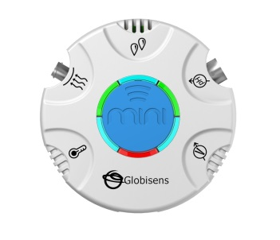For this experiment you will use the Mini to read data rather than record data, so you will need to be connected to the GlobiLab software during measuring portion of the experiment. Use the directions in Getting to Know the Mini if you need assistance in setting up the Mini through the GlobiLab software.
- Sensor Selection - select Voltage
- Sampling Rate - Manual
- Number of Samples - select 100
Select the meter display from the Display type drop down menu. From the bottom of the screen, select the single meter option. Left click on the meter and select Voltage from the sensor list. Select the full circle meter display (first option). Click OK.
Experiment Set Up
You will need to build your batteries before measuring their output. 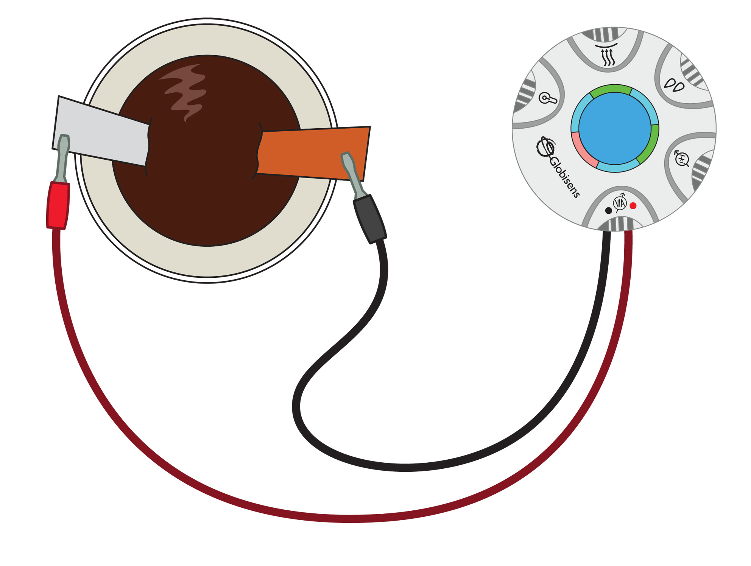
Soda Powered Battery
- Pour the contents of the soda into the plastic cup.
- With the scissors/tin snips, carefully cut a strip of aluminum from the soda can. The strip should be about 10 cm (the height of the can) by 1 cm wide. (You can also purchase aluminum strips if you wish).
- With the sand paper, sand both sides of the aluminum strip. This helps to remove any paint or plastic coating from the aluminum.
- Bend both the aluminum and copper strips and hang them over the lip of the cup so that about 3 cm is hanging on the outside of the cup with the remaining 7 cm in the cup. Try to have at least 5 cm of the strip immersed in the soda.
Salt Water Powered Battery
- Pour 350 ml of water into the plastic cup.
- Add 15 ml of table salt to the water and stir until completely dissolved.
- From the empty soda can, cut a strip of aluminum approximately 10 x 1 cm.
- Bend both the aluminum and zinc strips and hang the over the lip of the cup so that about 3 cm is hanging on the outside of the cup with the remaining 7 cm in the cup. Try to have at least 5 cm of the strip immersed in the soda.
Coin Powered Battery
- Mix 250 ml cup vinegar with 15 ml of salt and stir until completely dissolved.
- Using a quarter as a guide, cut 10 circles of construction paper. Put them in the vinegar-salt mixture to soak.
- Using a quarter as a guide, cut 10 circles of aluminum foil.
- Begin making your battery by stacking, in alternating layers in this order: foil, paper, quarter, until you have used all 10 quarters. You may want to do this inside a paper coin wrapper to make it easier to keep the stack together.
- Slip the stripped end of a piece of the copper wire under the bottom of the stack. Leave the other stripped end free so that you can touch it with the end of the banana clip.
Lemon Battery (you can also do this with a potato)
- Roll the lemon gently on the table to break open some of the cell walls and produce juice inside the lemon.
- Insert a copper strip into the lemon. Insert a zinc strip into the lemon. Be sure that at least 3 cm of the strip is inside the lemon.
Experiment Procedure
- Set the GlobiLab software to meter view and select the single meter icon from the bottom of the screen.
- Double click on the meter and select Voltage from the drop down menu and the first meter from the row of meter types.
- Click the Set Range button and set the Minimum value to -2.0 and the Maximum value to 2.0. Hit OK.
- On the soda powered battery, touch one clip to the copper strip and the other clip to the aluminum strip. If you get a negative reading, reverse the cables. Record your electrical output in volts on your Battery data sheet. Your screen will look something like this:
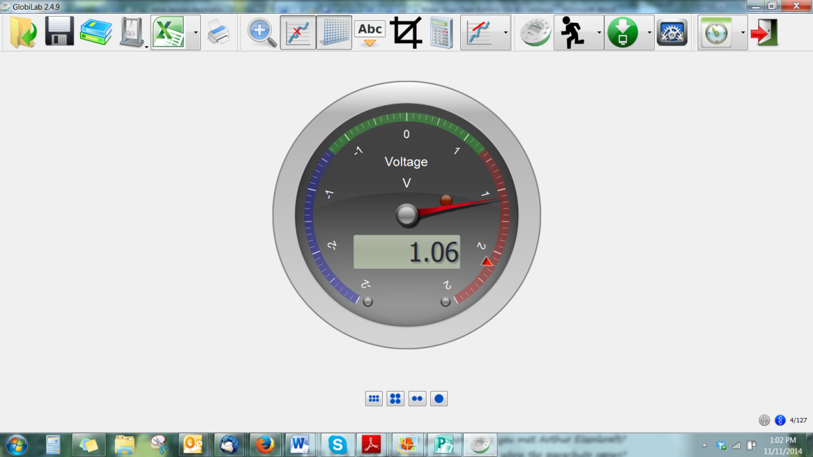
- On the salt water powered battery, touch one clip to the copper strip and the other clip to the aluminum strip. If you get a negative reading, reverse the cables. Record your electrical output in volts on your Battery data sheet.
- On the coin powered battery, touch one clip to the copper strip and the other clip to the aluminum strip. If you get a negative reading, reverse the cables. Record your electrical output in volts on your Battery data sheet.
- On the lemon powered battery, touch one clip to the copper strip and the other clip to the aluminum strip. If you get a negative reading, reverse the cables. Record your electrical output in volts on your Battery data sheet.
Questions & Observations
- On the soda powered battery, which metal was the anode (+/red)? Was this the same for all of the batteries? Why do think this is?
- What did you observe when you measured output for your batteries?
- Describe what is happening to produce electricity in your batteries.
- Was one type of battery more efficient than another? If so, which one?
Extension Activity
- Attach a piece of wire to each of the electrodes of one of your batteries and use the battery to light a small LED diode. Leave it attached to see how long the battery will power the diode. Observe the electrodes for any changes once the battery has “died.”
- To make a soda-powered or a salt-water-powered battery stronger, fill multiple plastic cups as described. Then, connect the metal strips on each cup with the opposite type of strip on the cup next to it using clip leads. For example, a copper strip should be connected with an aluminum strip.
- Try using a zinc strip instead of the copper in the soda-powered battery to see if/how it affects electrical output.
- Experiment with different electrolytes in the cup batteries to see if/how they affect electrical output. Try making a cup battery with the remaining vinegar-salt solution and electrodes of copper and zinc. You might also try adding some hydrogen peroxide to the salt water battery solution. You can also use Chlorine bleach as another option but the hydrogen peroxide is safer and has no odor.
- Experiment with other fruits and vegetables to see if they are effective in acting as an electrolyte for a battery (hint: try a potato).

Battery Powered Data Sheet
Battery Type | Voltage Produced
Soda Powered Battery
Salt Water Powered Battery
Coin Powered Battery
Lemon Powered Battery
Additional Experimental Batteries | Voltage

NGSS Standards
Performance Expectations
- Make observations to provide evidence that energy can be transferred from place to place by sound, light, heat, and electric currents. 4-PS3-2
- Apply scientific ideas to design, test, and refine a device that converts energy from one form to another. 4-PS3-4

Science and Engineering Practices
- Make observations to produce data to serve as the basis for evidence for an explanation of a phenomenon or test a design solution. Ask questions that can be investigated and predict reasonable outcomes based on patterns such as cause and effect relationships.
- Use evidence (e.g. measurements, observations, patterns) to construct an explanation.
- Apply scientific ideas to solve design problems.

Disciplinary Core Ideas

PS3.A: Definitions of Energy.
  - Energy can be moved from place to place by moving objects or through sound, light, or electric currents.
- PS3.B: Conservation of Energy and Energy Transfer.
  - Energy is present whenever there are moving objects, sound, light, or heat. When objects collide, energy can be transferred from one object to another, thereby changing their motion. In such collisions, some energy is typically also transferred to the surrounding air; as a result, the air gets heated and sound is produced.
  - Light also transfers energy from place to place.
  - Energy can also be transferred from place to place by electric currents, which can then be used locally to produce motion, sound, heat, or light. The currents may have been produced to begin with by transforming the energy of motion into electrical energy.
- PS3.D: Energy in Chemical Processes and Everyday Life
  - The expression “produce energy” typically refers to the conversion of stored energy into a desired form for practical use.
- ETS1.A: Defining and Delimiting Engineering Problems
  - Possible solutions to a problem are limited by available materials and resources (constraints). The success of a designed solution is determined by considering the desired features of a solution (criteria). Different proposals for solutions can be compared on the basis of how well each one meets the specified criteria for success or how well each takes the constraints into account.

Crosscutting Concepts
- Energy can be transferred in various ways and between objects.
- Engineers improve existing technologies or develop new ones.
- Over time, people's needs and wants change, as do their demands for new and improved technologies.
- Interdependence of Science, Engineering, and Technology
- Knowledge of relevant scientific concepts and research findings is important in engineering.
- Science affects everyday life.
- Most scientists and engineers work in teams.

Common Core State Standards Connections
ELA/Literacy
- W.4.7 - Conduct short research projects that build knowledge through investigation of different aspects of a topic.
- W.4.8 - Recall relevant information from experiences or gather relevant information from print and digital sources; take notes and categorize information, and provide a list of sources.

