Coping With a Warm Environment
Introduction
Perspiration
If you live in a warm environment, you know that your body sweats to cool down. Most people sweat in hot weather. If you exercise and produce more body heat than usual, you will sweat even more. Sweating is one way that humans and some other mammals cope with a warm or hot environment.
Sweating allows the body to regulate its temperature. Sweating causes a decrease in core temperature through evaporative cooling at the skin surface. As high energy molecules evaporate from the skin, releasing energy absorbed from the body, the skin and superficial vessels decrease in temperature. Cooled blood then returns to the body's core and counteracts rising core temperatures.
There are two situations in which the nerves will stimulate the sweat glands, causing perspiration: during physical heat and during emotional stress. In general, emotionally induced sweating is restricted to palms, soles, armpits, and sometimes the forehead, while physical heat-induced sweating occurs throughout the body.
People have an average of two to four million sweat glands. But how much sweat is released by each gland is determined by many factors, including gender, genetics, environmental conditions, age or fitness level, with fitness level and weight as major factors. The greater an individual’s weight the faster the sweat rate will increase because the body must exert more energy to function and there is more body mass to cool down. Additionally, individuals who are extremely fit will start sweating earlier and easier. Individuals who are physically fit find that the body becomes more efficient at regulating the body's temperature and sweat glands adapt along with the body's other systems.
In humans, sweating is primarily a means of thermoregulation. Adults sweat as much as 2-4 liters per hour or 10-14 liters per day. Children sweat far less prior to puberty. Evaporation of sweat from the skin surface has a cooling effect and so in hot weather, or when the individual's muscles heat up due to exertion, more sweat is produced.
Animals with few sweat glands, such as dogs, accomplish similar temperature regulation by panting. This allows water to evaporate from the moist lining of the mouth and nose. Monkeys, apes and horses have armpits that sweat like those of humans. Although sweating is found in a wide variety of mammals, very few produce large amounts of sweat in order for cooling purposes.
Measurements to be taken
In this investigation, students will measure environmental temperature and humidity.
Materials needed
- Mini
- External temperature sensor
- Moist towelette/baby wipe
- Rubber band
- Water
- Clear plastic bag (large enough for Mini and your hand)

Mini Set Up
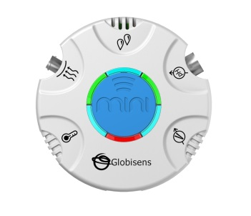For this experiment you will setup the Mini from the GlobiLab software menu. Use the directions in Getting to Know the Mini if you need assistance in setting up the Mini through the GlobiLab software.
Part 1 – Evaporative Cooling
- Sensor Selection - select the External Temperature
- Sampling Rate - 1/second
- Number of Samples - select 1000

Part 2 – Sweat Production
- Sensor Selection - select the External Temperature and Humidity
- Sampling Rate - 1/second
- Number of Samples - select 1000
When you hit the Run button, the green LED lights will circle, and then a light will show for about 3 seconds at the temperature and humidity sensor icons indicating that the external temperature and humidity sensors are “live.”
Experiment Procedure
Part 1 – Evaporative Cooling
- Push the Run button to begin your data collection and collect about 10 seconds of data.
- Wrap the baby wipe around the last 3 cm of the External Temperature probe. Slowly wave the sensor in the air and observe and record any temperature changes.
- Blow on the sensor from a distance of 20 centimeters. It is important not to be too close or the warmth of your breath will affect the results. Observe and record any temperature changes.
- Push the Stop button to end this data collection.
- Remove the cloth from the end of the External Temperature sensor. Press the Stop button to end the data collection.
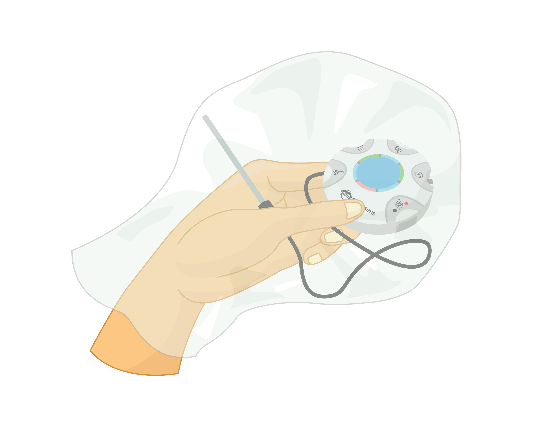Part 2 – Sweat Production
- Holding the Mini in your hand, place it and the External Temperature sensor inside a clear plastic bag.
- Seal the bag around your wrist with the rubber band or with tape. Be sure to not touch the metal part of the temperature sensor with you hand.
- Push the Run button to begin your data collection.
- Let the data collection run for 10 minutes before pushing the Stop button.
Part 3 Data Analysis
- Connect the Mini to the GlobiLab software via a Bluetooth connection and use the Download button to download the first data collection.
- Use the Statistics tool to discover the maximum and minimum temperature values. Label these points on your graph using the Annotation tool.
- Select the Marker button and put a marker on the line at the beginning of the experiment. A pop up window will give you the exact temperature at this point in time.
- Use the Annotation tool to add text describing the conditions at this point and the exact temperature.
- Using your mouse, slide the marker along the line to the point where you were waving the sensor and add a label with condition and temperature.
- Using your mouse, slide the marker along the line to the point where you were blowing the sensor and add a label with condition and temperature.
- Save your work after you’ve added the labels. Your graph will look something like this. Be sure to save your graph.
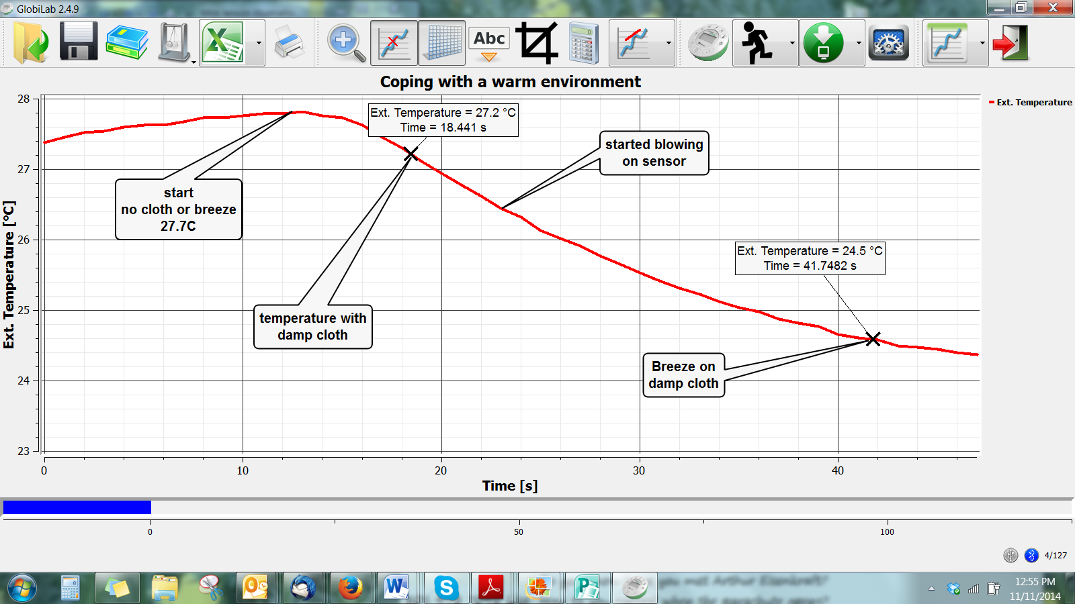
- Use the Download button to download the second data collection.
- Press the Statistics button and observe the maximum and minimum temperature values. Be sure to label these points on your graph.
- Select the Marker button and click to place a marker on highest temperature on your graph line. A pop up window will give you the exact temperature at this point in time. Click again to put a marker at the lowest temperature point on your graph line.
- Use the Annotate tool to label the maximum and minimum temperature points. Include the temperature reading at those points in your label.
- In the upper right side of the screen, click on the humidity line to set the y axis to humidity.
- Press the Statistics button and observe the maximum and minimum humidity values. Be sure to label these points on your graph.
- Select the Marker button and click to place a marker on highest humidity reading on your graph line. A pop up window will give you the exact humidity at this point in time. Click again to put a marker at the lowest humidity reading on your graph line.
- Use the Annotate tool to label the maximum and minimum humidity readings. Include the humidity reading at those points in your label. Your graph will look something like this:
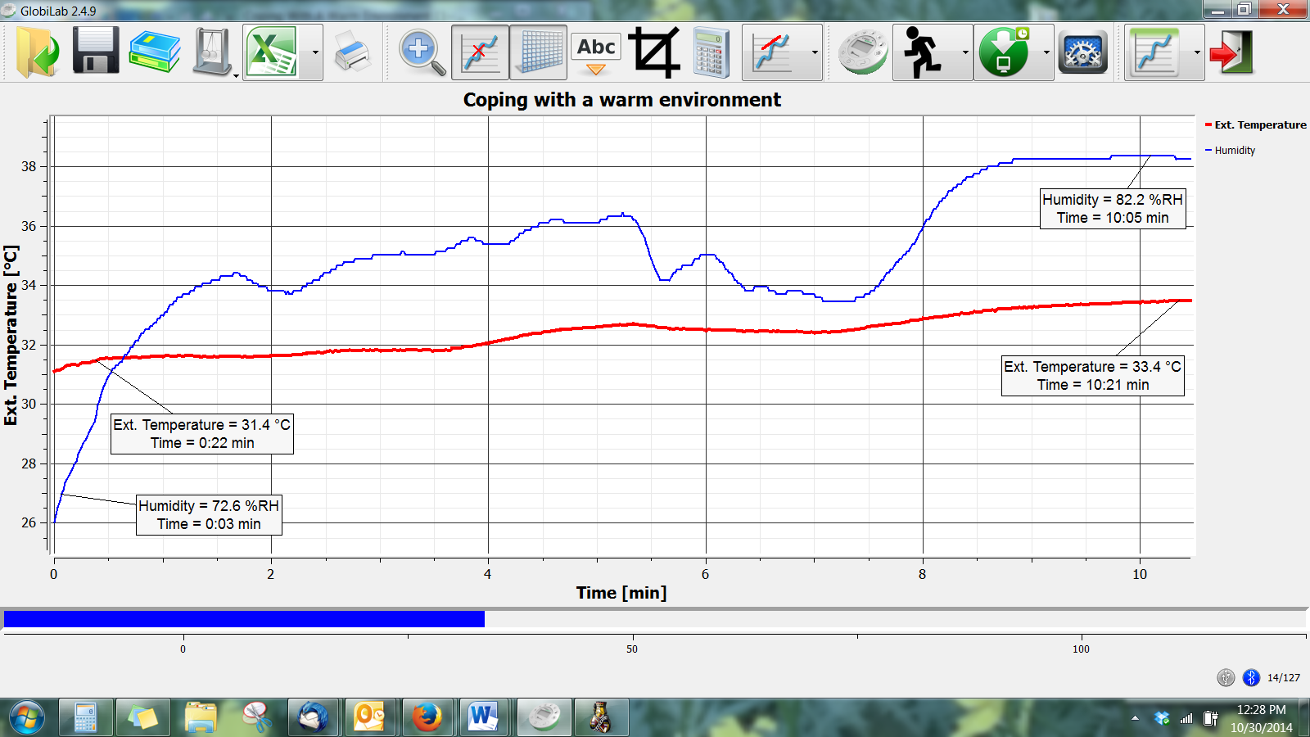
Questions & Observations
Part One – Evaporative Cooling
- What happened to the temperature as the water in the cloth evaporated?
- Which of the conditions that you tested produced the greatest level of cooling? Why did this happen?
- Predict what would happen if you’d done this with cold or ice water? (Ask your teacher if you can test your theory).
- How are the temperature and humidity graph lines the same? How are they different?
- Why didn’t both lines hit their maximum point at the same time?
- Think about how your hand felt during the experiment. How do the graph results reflect what you were feeling?
- Where did the humidity come from?
- Why didn’t your hand get cooler from the evaporation of sweat?
- What could you have done to help cool your hand?
Part 2 – Sweat Production
- How are the temperature and humidity lines the similar? How are they different?
- Why didn’t both lines hit their maximum point at the same time?
- Think about how your hand felt during the experiment. How do the graph results reflect what you were feeling?
- Where did the humidity come from?
- Why didn’t your hand get cooler from the evaporation of sweat?
- What could you have done to help cool your hand?

Florida Next Generation Standards Correlation

- SC.5.N.1.1 - Define a problem, use appropriate reference materials to support scientific understanding, plan and carry out scientific investigations of various types such as: systematic observations, experiments requiring the identification of variables, collecting and organizing data, interpreting data in charts, tables, and graphics, analyze information, make predictions, and defend conclusions.
- SC.5.N.1.6 - Recognize and explain the difference between personal opinion/interpretation and verified observation.
- SC.2.L.14.1 - Distinguish human body parts (brain, heart, lungs, stomach, muscles, and skeleton) and their basic functions.
- SC.5.L.14.1 - Identify the organs in the human body and describe their functions, including the skin, brain, heart, lungs, stomach, liver, intestines, pancreas, muscles and skeleton, reproductive organs, kidneys, bladder, and sensory organs.

Common Core State Standards Connections

Mathematics
- MACC.5.MP.5: Use appropriate tools strategically
- MACC.5.MP.8: Look for and express regularity in repeated reasoning

