Conductors and Insulators
Introduction
Conductors provide the path for the electrons to follow from the negative pole to the positive pole of the battery, just as a hose forms the path for water to flow through from the faucet to the nozzle. Some materials are easier for electrons to move through freely and evenly without accumulating in one place. These materials are called conductors. Most good conductors are metal or metal alloys.
Materials that are poor conductors of electrons are called insulators. Electrons do not move freely through these materials, so they are often used to cover the outside of electric wires or electrical equipment. Insulators are nonmetals; rubber, wood, glass, cloth, or plastics.
All materials contain atoms and all atoms have electrons. Whether a material allows electricity to pass through it easily, though, depends on the structure of the atom and the ease with which it allows its electrons to be moved.
The best conductors are usually metals because their electrons move easily. Non-metals tend to hold on to their electrons more tightly, which makes them poor conductors. Those atoms which hold their atoms most tightly make the best insulators.
The list below shows some common conductors and insulators. They are arranged in order, with the most efficient conductors and insulators at the top of each list. Compare this list to the results obtained in this activity.

Good Conductors | Good Insulators
Silver | Amber
Copper | Hard rubber
Gold | Nylon
Aluminum | Porcelain
Brass | Wax – crayons or candles
Ion | Glass
Lead | Wood
Mercury | Very pure water
Graphite | Air
Water containing dissolved minerals

Measurements to be taken
In this investigation, students will measure the amount of electrical current flowing through different types of circuits.
Materials needed
- Mini with banana cables
- D Cell battery
- Empty toilet paper tube
- Masking tape
- Steel wool pad (no soap)
- Nails (2)
- Rubber bands (2)
- Insulated copper wire
- Items to test as conductors – popsicle stick, plastic knife, metal spoon/fork, aluminum foil, kitchen sponge, nail, paper clip, ball point pen, pencil, glass of water)

Mini Set Up
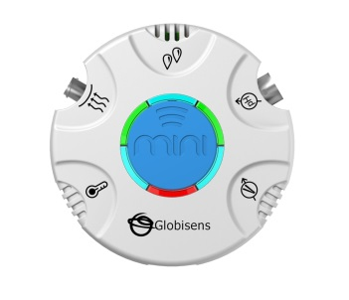For this experiment you will use the Mini to read data rather than record data, so you will need to be connected to the GlobiLab software during measuring portion of the experiment. Use the directions in Getting to Know the Mini if you need assistance in setting up the Mini through the GlobiLab software.
- Sensor Selection - select Current
- Sampling Rate - Manual
- Number of Samples - select 100
Select the meter display from the Display type drop down menu. From the bottom of the screen, select the single meter option. Left click on the meter and select the Current sensor. Select the full circle meter display (first option). Click OK.
Experiment Set Up
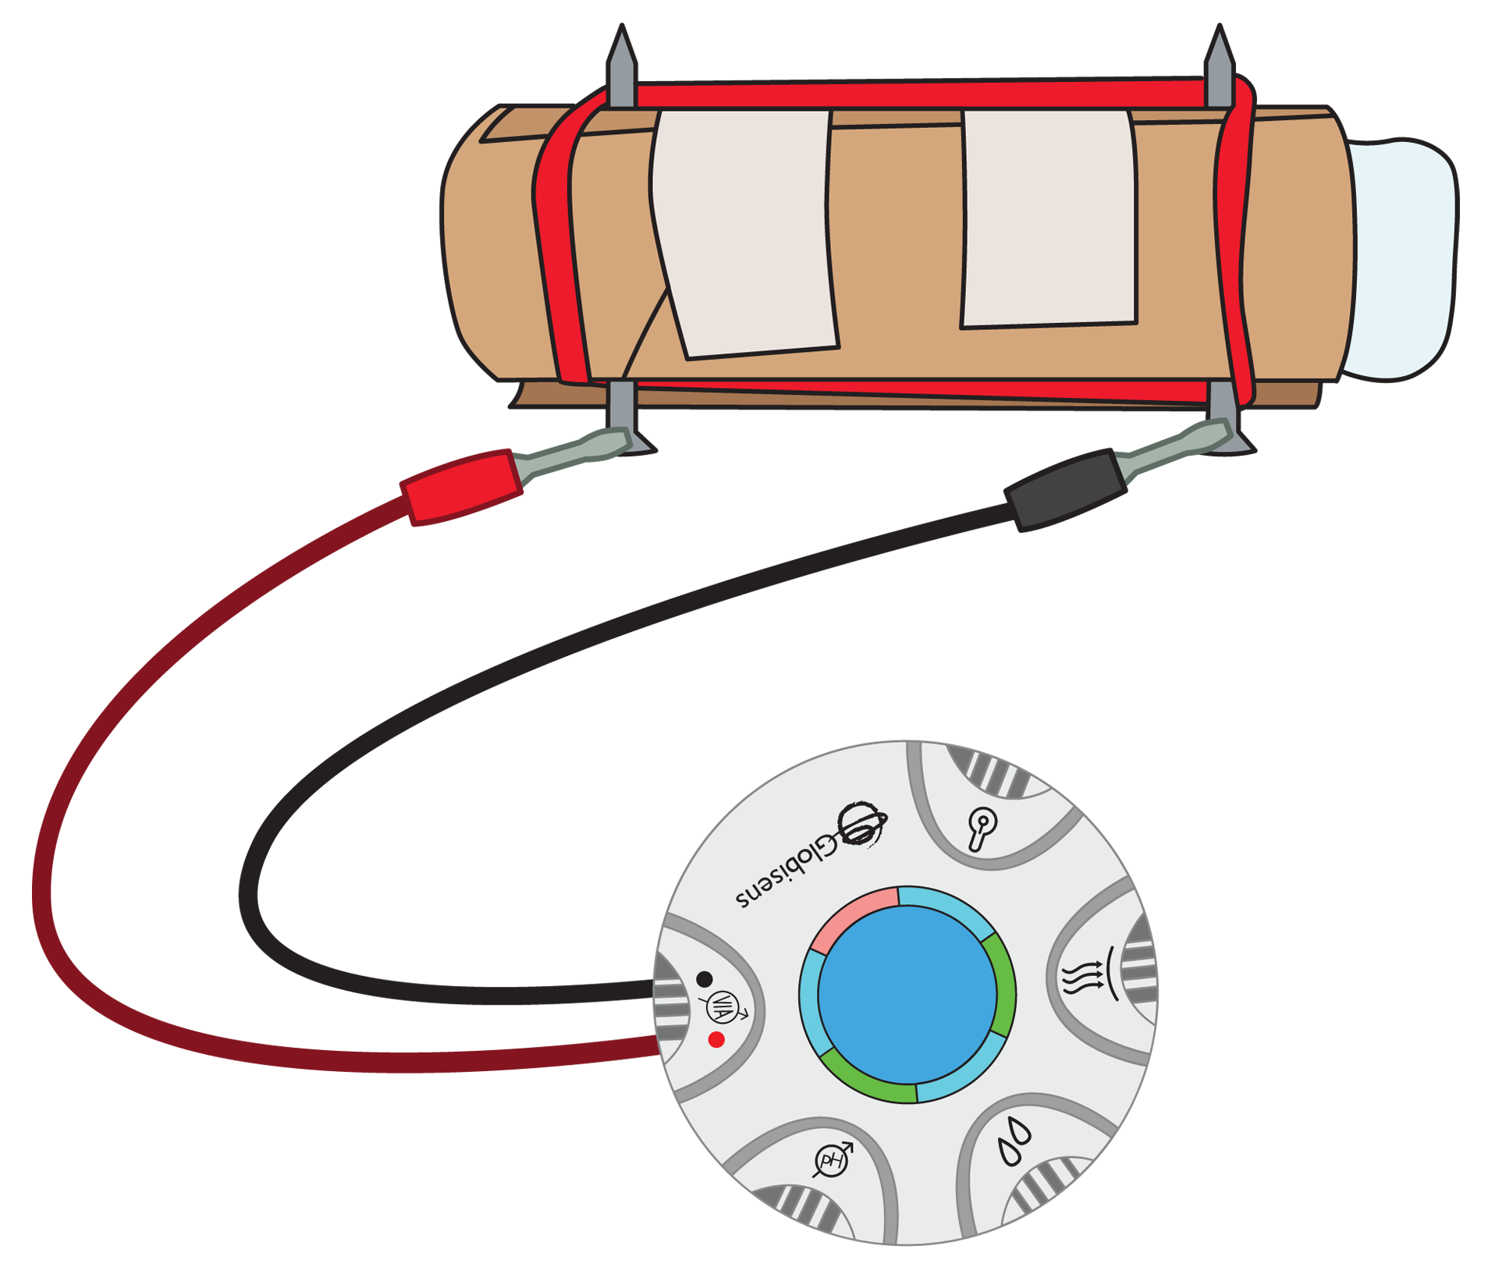

Have students build a battery holder using the steps below:
- Cut the toilet paper tube open with a single slit running lengthwise.
- Place the battery inside the tube and tape the tube shut so that the battery fits snugly inside the tube.
- Place half of the steel wool pad in each end of the tube so that it touches the anode/cathode ends of the battery.
- Gently push a nail through each end of the tube so that it goes through the steel wool and comes out the other side of the tube. Be careful not to hit the battery.
- Put a rubber band over the nails on each side of the tube. The rubber bands should be tight enough to pull the nails towards each other.
- Strip about 1” of insulation from each end of two 10” pieces of insulated copper wire. Wrap the bare end of a piece of insulated copper wire around each of the nails and make a small loop with the other bare end.
- Discuss the terms insulator and conductor. Ask students to look at the objects provided and predict which they think will be insulators and which they think will be conductors.
Experiment Procedure
- Students should test their predictions about which objects are conductors/insulators using the following method:
  - Hold the ends of the wires to each end of an item being tested. Then touch each of the banana clips to the item being tested; one at either end, slightly closer than where the two wire ends attach.
  - Observe the meter to see if and how much current is flowing through the item being tested. Your screen will look something like this:
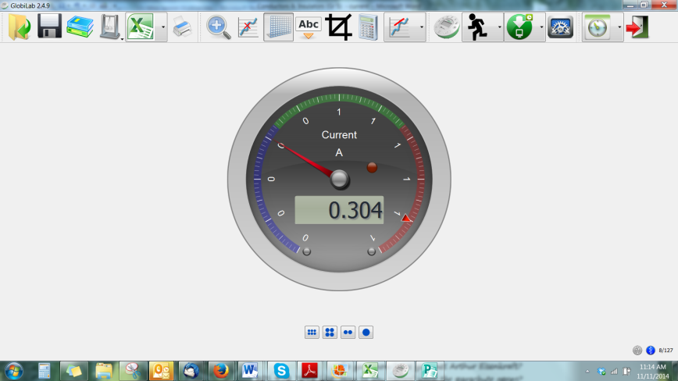
- Record the item and the amount of current (if any) on the data sheet.
Questions & Observations
- Which items were conductors and which were insulators? How did you know?
- Were you surprised by any of your results? Which ones and why?
- Before you tested the objects, how did you decide if you thought an object would be a conductor or an insulator?
- Compare the objects that you have discovered are conductors. What do they have in common?
- Is water a conductor or an insulator? Why would it be dangerous to be wet or standing in water when working with electricity?
Extension Activity
Try testing the conductivity of different water samples. Be sure to include distilled water (pure) as well as tap water, local pond water and sea water.

Insulators/Conductors
Predicted Insulators |  | Predicted Conductors
Actual Insulators | Amount of Current | Actual Conductors | Amount of Current

NGSS Standards

Performance Expectations
Develop a model to describe that matter is made of particles too small to be seen. 5-PS1-1

Science and Engineering Practices
- Develop a model to describe phenomena
- Use evidence (e.g. measurements, observations, patterns) to construct an explanation.
- Apply scientific ideas to solve design problems.
- Make observations and measurements to produce data to serve as the basis for evidence for an explanation of a phenomenon.

Disciplinary Core Ideas
- PS1.A: Structure and Properties of Matter
- Matter of any type can be subdivided into particles that are too small to see, but even then the matter still exists and can be detected by other means. A model showing that gases are made from matter particles that are too small to see and are moving freely around in space can explain many observations, including the inflation and shape of a balloon and the effects of air on larger particles or objects.
- Measurements of a variety of properties can be used to identify materials. (Boundary: At this grade level, mass and weight are not distinguished, and no attempt is made to define the unseen particles or explain the atomic-scale mechanism of evaporation and condensation).

Crosscutting Concepts
- Scale, Proportion, and Quantity
- Natural objects exist from the very small to the immensely large.
- Standard units are used to measure and describe physical quantities such as weight, time, temperature, and volume.

Common Core State Standards Connections

ELA/Literacy
- RI.5.7 - Draw on information from multiple print or digital sources, demonstrating the ability to locate an answer to a question quickly or to solve a problem efficiently.
- W.5.7 - Conduct short research projects that use several sources to build knowledge through investigation of different aspects of a topic.
- W.5.8 - Recall relevant information from experiences or gather relevant information from print and digital sources; summarize or paraphrase information in notes and finished work, and provide a list of sources.
- W.5.9 - Draw evidence from literary or informational texts to support analysis, reflection, and research.

Mathematics
- 5.MD.C.3 - Recognize volume as an attribute of solid figures and understand concepts of volume measurement.
- 5.NBT.A.1 - Recognize that in a multi-digit number, a digit in one place represents 10 times as much as it represents in the place to its right and 1/10 of what it represents in the place to its left.
- MP.2 - Reason abstractly and quantitatively.
- MP.4 - Model with mathematics.
- MP.5 - Use appropriate tools strategically.

