All Charged Up (Gr 4)
Introduction
Around the time of World War I, American battery manufacturers, the War Industries Board, and a few government agencies got together to develop some nationally uniform specifications for the size of battery cells, their arrangement in batteries, their minimum performance criteria, and other standards. In 1924, industry and government representatives met again to figure out a naming system for all those cells and batteries they had just standardized. They decided to base it around the alphabet, dubbing the smallest cells and single-cell batteries “A” and went from there to B, C and D. There was also a "No. 6" battery that was larger than the others and pretty commonly used, so it was grandfathered in without a name change.
As battery technology changed and improved and new sizes of batteries were made, they were added to the naming system. When smaller batteries came along, they were designated AA and AAA. These newer batteries were the right size for the growing consumer electronics industry, so they caught on. C and D batteries also found a niche in medium- and high-drain applications. The mid-size A and B batteries didn’t have a market and pretty much disappeared from the U.S. market. A-sized batteries were used in early-model laptop battery packs and some hobby battery packs. B-sized batteries are still sometimes used in Europe for lanterns and bicycle lamps. According to Energizer, though, their popularity is dwindling there, too, and they might be completely discontinued.
Since batteries convert chemical potential energy directly into electricity, the capacity of a battery is directly proportional to its size. Additionally, the maximum current a battery can deliver is directly related to the area of the plates used. Car batteries can deliver as much as 500 Amperes for short periods because they have large plates with low internal resistance. A 12-Volt lantern battery can't get close to that high rating because their plate area is significantly smaller and their internal resistance is higher. A lantern battery might develop the right voltage, but it has no chance of starting your car.
Typically a D cell will last a lot longer than an AA or C cell for a given load because it simply stores more energy. The D cell is also capable of delivering much higher currents than their smaller counterparts. This is usually not necessary in consumer applications, but it's a direct result of larger plate area. The other reason batteries come in different sizes is simply a matter of practicality. A big battery will last a long time, but if it doesn't fit in your mini-flashlight, it's no good.
Battery Chemistry
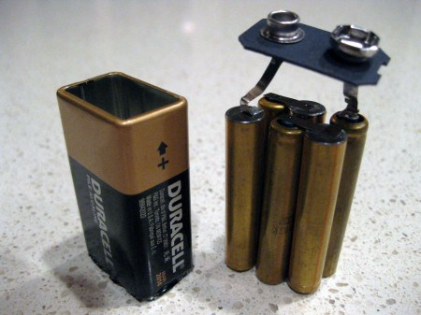Voltage is based upon the chemistry of the battery. The base unit of a battery is called a cell. When you combine two or more cells, you have a battery. But why do so many batteries produce the same voltage? The batteries that we are most familiar with (D, C, AA, AAA) are technically not batteries, but rather a single cell. Some of the first commercially available cells like Zinc-Carbon, produced a nominal 1.5 volts, due to the materials used. Newer cells made with different materials, like Manganese-Dioxide, would need to produce the same voltage if they were used as replacements for Zinc-Carbons. Surprisingly, many of the materials used in modern cells produce voltages ranging from 1.1-1.7 volts.
A single cell will have what is called a nominal voltage based upon what chemicals are used to make up the battery. The chemical reactions inside the cell will determine the output voltage. The capacity or run time can definitely be impacted by the size. Compare an alkaline AAA to a D cell. Even though they have the same voltage based upon the chemistry, the D has a much greater capacity based upon the volume of chemicals in the can.
If you want to change the voltage, the only way you can go is up by connecting the cells or batteries in a series connection (positive of one cell to positive of the other) as in a 9 volt battery. To increase capacity, but keeping the same voltage, connect the cells or batteries in a parallel connection (positive of one cell to negative of the other cell). Higher voltage batteries, like 9-volt and 6-volt lantern batteries are made up of several cells in series. If you have a dead 9-volt battery you can see the individual cells by carefully peeling off the casing. Avoid breaking any of the individual cells, you might expose yourself to dangerous chemicals. Alkaline 9-volt batteries are made up of 6 cells that are smaller than the standard "AAA" cell.
Measurements to be taken
Students will compare the voltage and current output of different sized batteries.
Materials needed
- Mini with banana cables
- Batteries – 1@ D, C, AA and AAA batteries
- Data Collection Sheet (master attached)
Mini Set Up
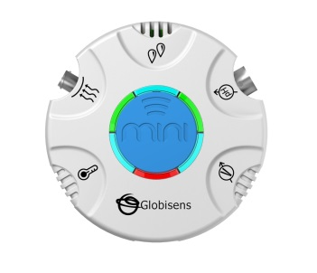For this experiment you will setup the Mini from the GlobiLab software menu. Use the directions in Getting to Know the Mini if you need assistance in setting up the Mini through the GlobiLab software.
For the first data collection:
- Sensor Selection - select Voltage
- Sampling Rate - Manual
- Number of Samples - select 10
When you push the Run button, the green LED lights will circle, indicating that the Mini is in Manual data collection mode.
Experiment Set Up
Prior to activity, set up lab stations with Mini, banana cables and batteries.
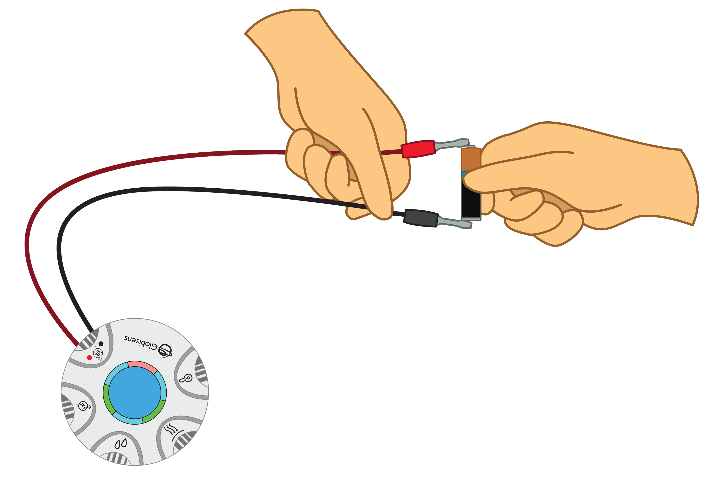
Experiment Procedure
- Set the graph type to bar graph. Start the GlobiLab software from the computer or tablet. The green LED lights should rotate around in a full circle.
- Working with a partner and the D battery, hold the red end of the banana cable to the anode (the positive (+) end) and the black end of the banana cable to the cathode (negative (-) end) of the D cell battery at the same time. Press the blue control button to take your first measurement. The LED lights should pause and a measurement bar should appear on the graph.
- With the C battery, hold the red end of the banana cable to the anode (the positive (+) end) and the black end of the banana cable to the cathode (negative (-) end) of the battery at the same time. Press the blue control button to take your first measurement. Each time you press the blue button, the LED lights should pause and a measurement bar should appear on the graph.
- With the AA battery, hold the red end of the banana cable to the anode (the positive (+) end) and the black end of the banana cable to the cathode (negative (-) end) of the battery at the same time. Press the blue control button to take your first measurement. The LED lights should pause and a measurement bar should appear on the graph.
- With the AAA battery, hold the red end of the banana cable to the anode (the positive (+) end) and the black end of the banana cable to the cathode (negative (-) end) of the battery at the same time. Press the blue control button to take your first measurement. The LED lights should pause and a measurement bar should appear on the graph.
- Download and save your data. Use the Annotation tool to add labels for each measurement. Add a photo of the battery and be sure to include the voltage level that you measured. Your graph will look something like this.
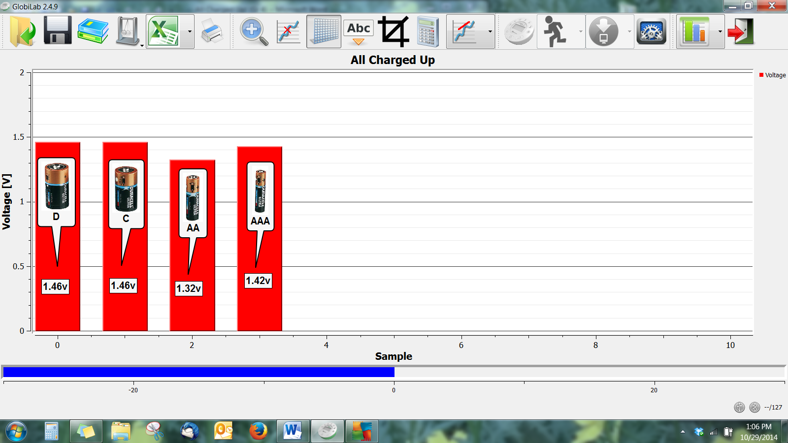
- Fill in the Data Collection Sheet with your measurements.
Questions & Observations
- What did you discover about the voltage output of different sized batteries? Do larger batteries produce a larger output? Do smaller batteries produce a lower output?
- What determines the amount of voltage that a battery can produce?
- Use what you've just discovered to explain why are batteries made in different sizes?
Extension Activity
- Try testing different brands of the same size battery to see if the voltage is consistent from brand to brand.
- Using several batteries and wire, create your own multi-cell battery. Measure the voltage output. It should roughly equal the sum of the voltages of the individual batteries.
- As a demonstration, carefully open a 9 volt battery to expose the inner cells.

Does Size Matter Data Collection Sheet
Battery Size | Voltage Produced
D Battery
C Battery
AA Battery
AAA Battery

Show Me
Draw your own version of the bar graph.
NGSS Standards

Performance Expectations
Apply scientific ideas to design, test, and refine a device that converts energy from one form to another. 4-PS3-4

Science and Engineering Practices
- Ask questions that can be investigated and predict reasonable outcomes based on patterns such as cause and effect relationships.
- Use evidence (e.g. measurements, observations, patterns) to construct an explanation.
- Apply scientific ideas to solve design problems.

Disciplinary Core Ideas
- PS3.D: Energy in Chemical Processes and Everyday Life
The expression “produce energy” typically refers to the conversion of stored energy into a desired form for practical use.
- ETS1.A: Defining and Delimiting Engineering Problems
Possible solutions to a problem are limited by available materials and resources (constraints). The success of a designed solution is determined by considering the desired features of a solution (criteria). Different proposals for solutions can be compared on the basis of how well each one meets the specified criteria for success or how well each takes the constraints into account.

Crosscutting Concepts
- Energy can be transferred in various ways and between objects
- Engineers improve existing technologies or develop new ones
- Over time, people's needs and wants change, as do their demands for new and improved technologies
- Interdependence of Science, Engineering, and Technology
- Knowledge of relevant scientific concepts and research findings is important in engineering
- Science affects everyday life
- Most scientists and engineers work in teams

Common Core State Standards Connections

ELA/Literacy
- W.4.7 - Conduct short research projects that build knowledge through investigation of different aspects of a topic.
- W.4.8 - Recall relevant information from experiences or gather relevant information from print and digital sources; take notes and categorize information, and provide a list of sources.

