Air Pressure
Introduction
Pressure is the amount of force pushing against a unit area of surface. In meteorology, air pressure (also known as atmospheric or barometric pressure) refers to the force that a column of air pushes down on a unit area of Earth’s surface. The tool used to measure air pressure is a barometer. The barometer uses a column of liquid or a type of metal spring which responds to an increase or decrease in air pressure. Examples of units of air pressure are “mmHg” or “inHg” (millimeters of Mercury or inches of Mercury, based on the use of Mercury in some barometers) and “hPa” (hectopascals, where the Pascal is a unit of pressure).
Air is a mixture of gases. When they are heated, they expand. When the gases are cooled, they contracted which caused the bottle to collapse. The force that air puts on other objects is called air pressure. The weight of the air in Earth's atmosphere is constantly putting pressure on everything because gravity pulls air down on objects. Air pressure can be very powerful. Air pressure pushes down on Earth at about 14 pounds per square inch. We do not usually feel this force because our bodies have air that presses outward to balance the air pressure.
In meteorology terms, air pressure is labeled as a high pressure system or a low pressure system. Cool air is heavier or denser and when it sinks and presses on the ground, this causes an area of high pressure. Warm air is lighter, or less dense, so it rises and causes an area of low pressure.
So what does all this mean?
A barometer is a weather instrument that measures air pressure. Barometers are used to predict weather changes. If the barometer rises, you have a high pressure system which usually brings sunny weather. If the barometer falls, you have a low pressure system which usually brings rain.
Measurements to be taken
In this investigation, students will measure the air pressure inside a plastic bottle.
Materials needed
- Mini with air pressure tube
- Dishpan with ice water
- Dishpan with very hot water
- 2 liter soda bottle with lid, label removed and thoroughly rinsed
- Scissors
- Modeling clay or duct/electrical tape
Mini Set Up
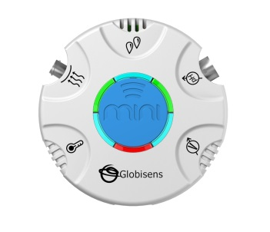For this experiment you will setup the Mini from the GlobiLab software menu. Use the directions in Getting to Know the Mini if you need assistance in setting up the Mini through the GlobiLab software.
- Sensor Selection - select Air Pressure
- Sampling Rate - 10/sec
- Number of Samples - select 3000
When you begin the data collection, the green LED lights will circle, and then pause for about 3 seconds at the air pressure sensor indicating that the air pressure sensor is “live.”
Experiment Set Up
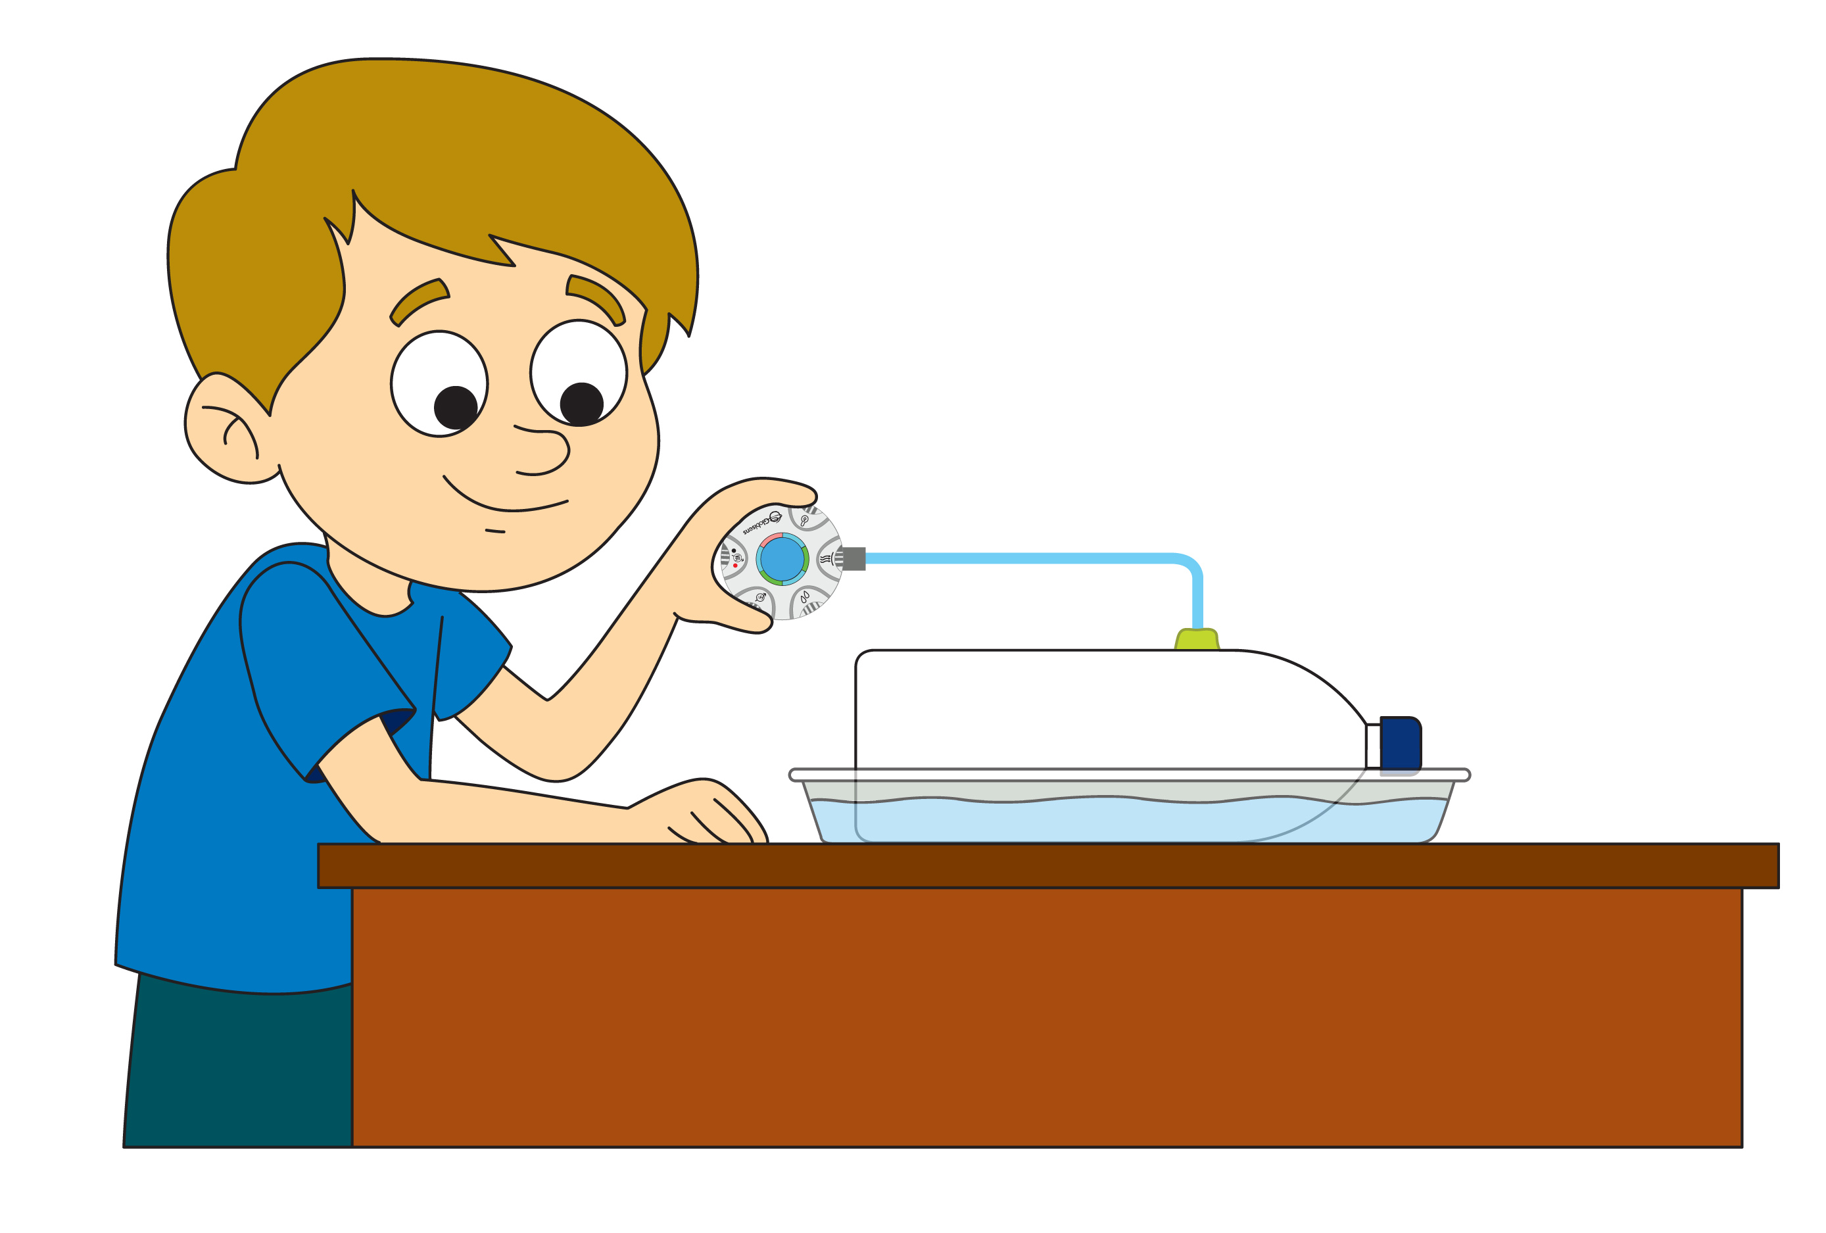
Prior to the activity, remove the labels and thoroughly rinse out the soda bottles. Using the scissors or a sharp knife, carefully make a small ”x” cut near the top of the bottle that is just large enough to insert the end of the air pressure tube. Using the modeling clay or the tape, create an air-tight seal between the bottle and the tube. Allow the bottle to dry and put the bottle top back on tightly.
Experiment Procedure
- Connect the Mini to the air pressure tube and press the Run button.
- Place the bottle in the hot water bath and observe. (The bottle will expand some and feel very tight when you try to squeeze it).
- When the pressure stops increasing, remove the bottle from the hot water bath and observe.
- Place the bottle into the ice water bath and observe.
- When the pressure stops decreasing, remove the bottle from the cold water bath and observe.
- Press the Stop button.
- Use the Annotation feature to add labels showing where the bottle went into the hot water and the ice water. Use the marker to show the air pressure inside the bottle at these points. Your graph will look something like this:
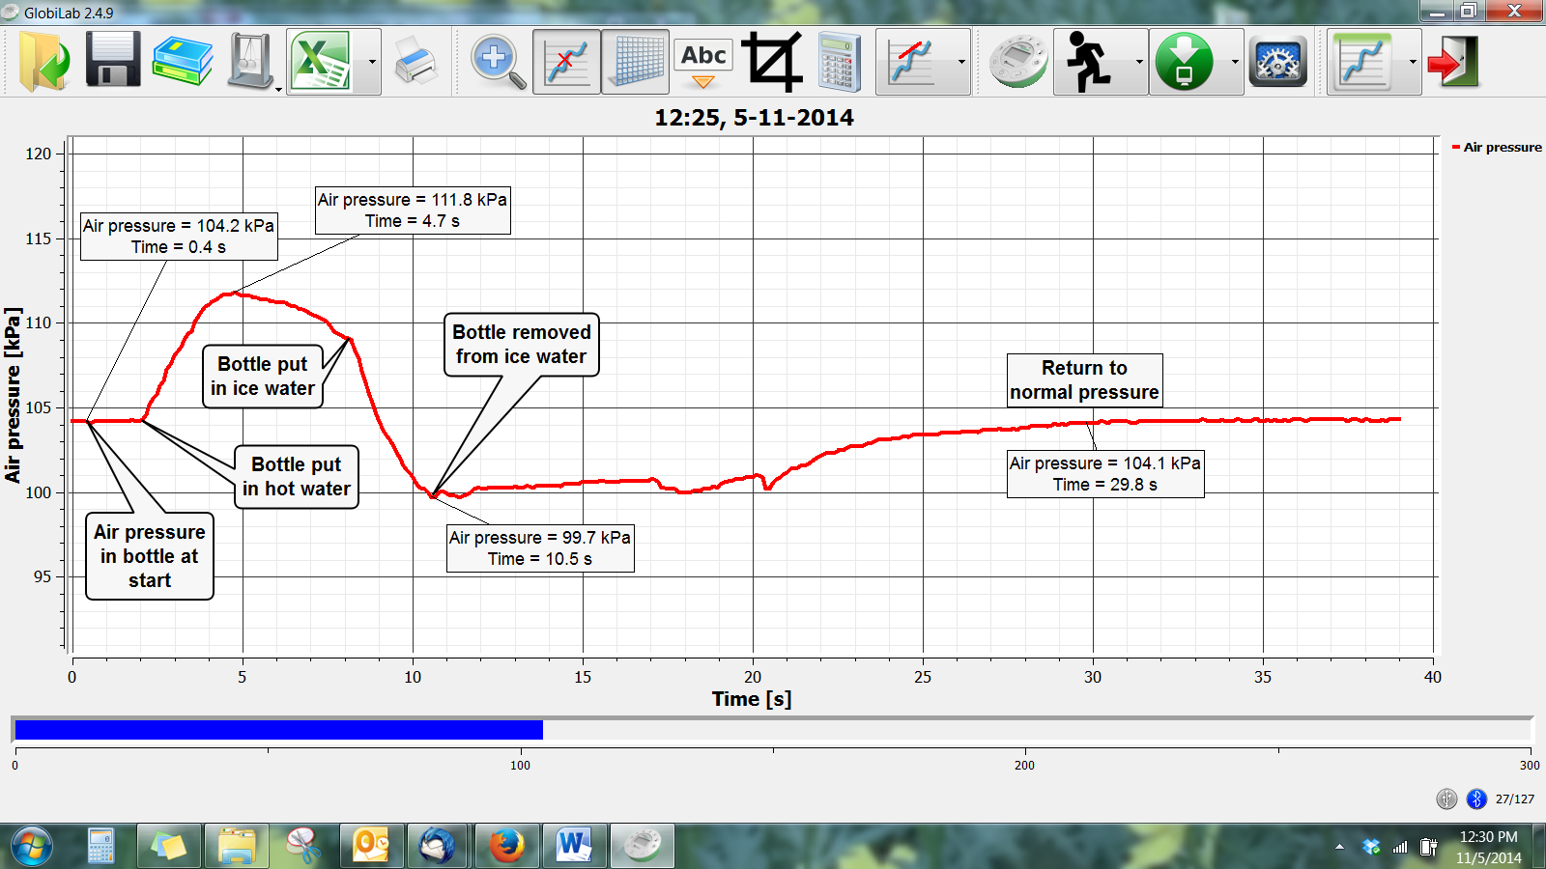
Questions & Observations
- What happened to the bottle in the hot water?
- What happened to the pressure inside the bottle in the hot water? Explain how this could cause what you observed.
- What happened when you removed the bottle from the hot water?
- What happened to the pressure inside the bottle when you removed it from the hot water? Explain how this could cause what you observed.
- What happened to the bottle in the cold water?
- What happened to the pressure inside the bottle in the cold water? Explain how this caused what you observed.
- What happened when you removed the bottle from the cold water?
- What happened to the pressure inside the bottle when you removed it from the cold water? Explain how this could cause what you observed.
Extension Activity
Try heating/cooling other types of closed containers to see if you can repeat these results (i.e. inflated balloon, yogurt container, etc.). Be careful not to create so much pressure that the container is damaged or a lid flies off.

Next Generation Science Standards

Performance Expectations
Develop a model to describe that matter is made of particles too small to be seen. 5-PS1-1

Science & Engineering Practices
Develop a model to describe phenomena.

Disciplinary Core Ideas
Matter of any type can be subdivided into particles that are too small to see, but even then the matter still exists and can be detected by other means. A model showing that gases are made from matter particles that are too small to see and are moving freely around in space can explain many observations, including the inflation and shape of a balloon and the effects of air on larger particles or objects.

Crosscutting Concepts
Natural objects exist from the very small to the immensely large.

Common Core State Standards Connections

ELA/Literacy
RI.5.7 - Draw on information from multiple print or digital sources, demonstrating the ability to locate an answer to a question quickly or to solve a problem efficiently.

Mathematics
- 5.MD.C.3 - Recognize volume as an attribute of solid figures and understand concepts of volume measurement.
- 5.MD.C.4 - Measure volumes by counting unit cubes, using cubic cm, cubic in, cubic ft., and improvised units.
- 5.NBT.A.1 - Recognize that in a multi-digit number, a digit in one place represents 10 times as much as it represents in the place to its right and 1/10 of what it represents in the place to its left.
- 5.NF.B.7 - Apply and extend previous understandings of division to divide unit fractions by whole numbers and whole numbers by unit fractions.
- MP.2 - Reason abstractly and quantitatively.
- MP.4 - Model with mathematics.

